PROJECT REPORT
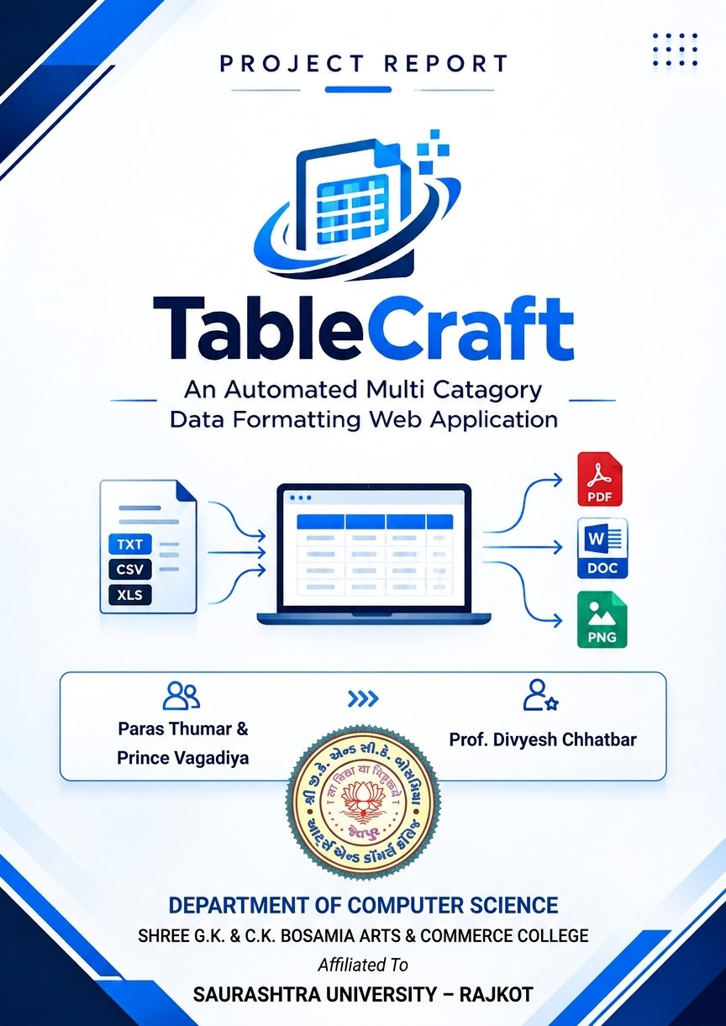
TABLECRAFT

An Automated Multi-Category Data Formatting Web Application
━━━━━━━━━━━━━━━━━━━━━━━━━━━━━━━━
BCA Semester – VI
Academic Year 2026–2027
G.K. & C.K. Bosamia College, Jetpur
HTML5 • CSS3 • Bootstrap 5 • JavaScript • PHP • MySQL
WampServer • Apache • phpMyAdmin

BCA Semester 5, 2026-2027

PROJECT OVERVIEW
BCA Semester 5, 2026-2027
TableCraft is a web-based application developed to simplify the creation, organization, editing, customization and export of structured data tables. It provides predefined categories for common data-management requirements and also supports custom table structures.

The application combines a responsive front end with PHP server-side processing and a MySQL relational database. It includes registration, login, category-based table creation, dynamic rows and columns, automatic calculations, appearance customization, persistent storage, searching, filtering and export to PDF, DOC and PNG.

Item | Details
Project Name | TableCraft
Project Type | Web Application
Purpose | Automated Multi-Category Data Formatting
Frontend | HTML5, CSS3, Bootstrap 5, JavaScript
Backend | PHP
Database | MySQL
Environment | WampServer / Apache
Database Tool | phpMyAdmin
Themes | Bright & Dark
Export | PDF, DOC, PNG

ACKNOWLEDGEMENT
We express our sincere gratitude to the faculty members and the college for providing the academic environment and guidance required to complete this project. We also acknowledge the value of practical learning through PHP, MySQL, JavaScript, HTML, CSS and Bootstrap during the development of TableCraft.
The project helped us understand the complete software-development cycle: gathering requirements, analyzing feasibility, designing data structures and interfaces, implementing CRUD operations, handling errors, testing application behaviour, and preparing the final implementation and documentation. We are also thankful to everyone who contributed feedback during the design and testing stages of the application.

INDEX
No. | Project Task | Page
1 | Requirement Gathering | 5
2 | Requirement Analysis | 7
3 | Feasibility Study | 9
4 | Data Information | 10
5 | Data Structure | 12
6 | Data Flow Diagram: Admin & Client | 16
7 | Designing: Admin & Client | 22
8 | Coding | 24
9 | Error & Solution | 81
10 | Testing | 87
11 | Implementation | 90
12 | Limitations | 92
13 | Conclusion | 93

1. REQUIREMENT GATHERING

1.1 Introduction
The first stage of the TableCraft project was requirement gathering. The objective was to identify difficulties users face when creating, organizing, formatting and exporting structured information. Manual spreadsheet or HTML-table creation can be inconvenient when different data types require different structures.

1.2 Main Requirements
- User registration and login.
- Personal dashboard and category navigation.
- Predefined table categories.
- Dynamic row and column editing.
- Column rename and reorder operations.
- Table title, font, accent-color and theme customization.
- Automatic calculations for applicable categories.
- MySQL persistence.
- Search and category filtering.
- PDF, DOC and PNG export.

1.3 Categories
- Student Record
- Shop Order
- Employee Info
- Library Book List
- Product Stock
- Commercial Category
- Custom Category Editor

1.4 Technical Requirements

Technology | Purpose
HTML5 | Structure
CSS3 | Styling
Bootstrap 5 | Responsive UI
Bootstrap Icons | Interface icons
JavaScript | Dynamic table behavior
PHP | Server-side processing
MySQL | Database
WampServer | Local server
phpMyAdmin | Database administration

2. REQUIREMENT ANALYSIS

The requirements were converted into functional and non-functional modules. The application is divided into authentication, dashboard, category, table editor, storage, library and export responsibilities.

2.1 Functional Requirements

Registration
Creates a new account after validating name, email, password and confirmation.

Login
Authenticates registered users and creates a PHP session.

Dashboard
Provides navigation, category cards, quick actions and recent tables.

Category Tables
Starts a table using predefined category columns.

Dynamic Editing
Supports adding/deleting rows, adding/deleting/renaming/reordering columns and editing cells.

Automatic Calculation
Calculates quantity × price, stock value, subtotal, discount and totals where applicable.

Customization
Supports Bright/Dark mode, accent color and font selection.

Persistence
Saves table metadata, columns, rows and cells to MySQL.

My Tables
Allows searching, filtering, opening, editing and deleting saved tables.

Export
Produces PDF, DOC and PNG outputs.

2.2 Non-Functional Requirements
- Usability
- Responsive design
- Maintainability
- Validation and reliability
- Authenticated ownership checks
- Acceptable performance for normal project-sized datasets

3. FEASIBILITY STUDY

3.1 Technical Feasibility
The project is technically feasible because it uses standard web technologies supported by WampServer. No specialized hardware is required.

3.2 Economic Feasibility
The main development technologies are freely available, so implementation cost is low.

3.3 Operational Feasibility
The category-based interface, clear navigation and direct table editing make the system usable for people with basic computer knowledge.

3.4 Schedule Feasibility
The work was divided into defined phases from requirements through implementation, making the academic schedule manageable.

3.5 Result
TableCraft is technically, economically, operationally and schedule feasible for the intended academic project scope.

4. DATA INFORMATION

Data is the central component of TableCraft. Raw user input is converted into organized table records and stored in a relational database.

Type | Examples
Text | Names, titles, descriptions, categories
Number | Quantity, marks, roll number, attendance
Date | Order, joining, issue and return dates
Currency | Price, salary, total, stock value

4.1 Student Record
Roll No. | Name | Class | Subject | Marks | Attendance
1 | Student A | BCA | PHP | 82 | 91%
2 | Student B | BCA | MySQL | 78 | 88%

4.2 Shop Order
Order ID | Customer | Product | Qty. | Price | Total
ORD001 | Customer A | Product A | 2 | 500 | 1000

4.3 Employee Information
Employee ID | Name | Department | Designation | Joining Date | Salary
EMP001 | Employee A | IT | Developer | 01-06-2026 | 25000

4.4 Library Book List
Book ID | Title | Author | Category | Issue Date | Status
B001 | Database Systems | Author A | Computer | 05-08-2026 | Issued

4.5 Product Stock
Product ID | Product | Category | Qty. | Price | Stock Value
P001 | Product A | General | 20 | 100 | 2000

4.6 Commercial Data
Commercial tables contain item, quantity, price, discount percentage and total. The system calculates subtotal, discount amount and final total dynamically.

5. DATA STRUCTURE

The MySQL database separates users, table metadata, columns, rows and cells. This relational structure supports dynamic table creation while maintaining ownership and data consistency.
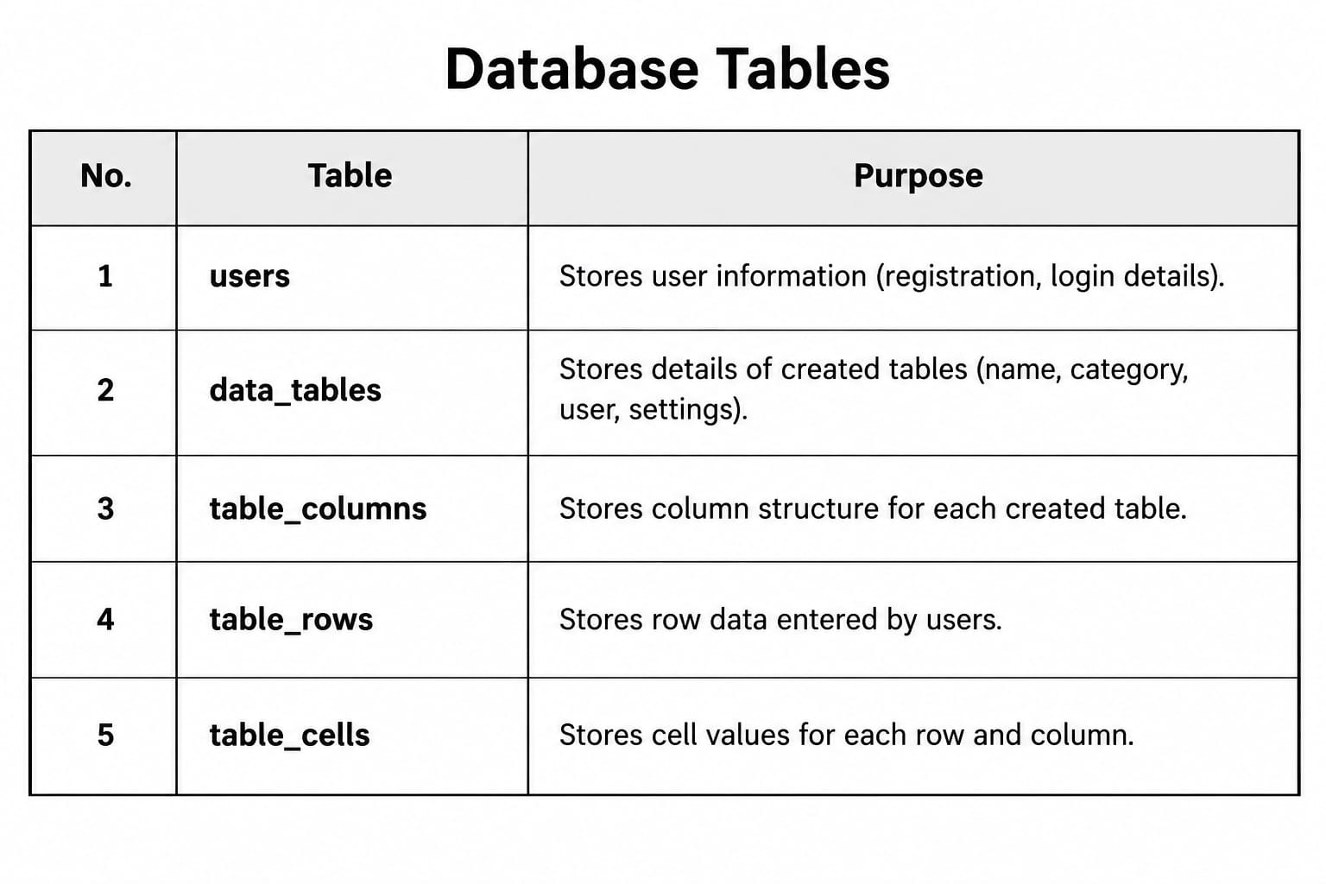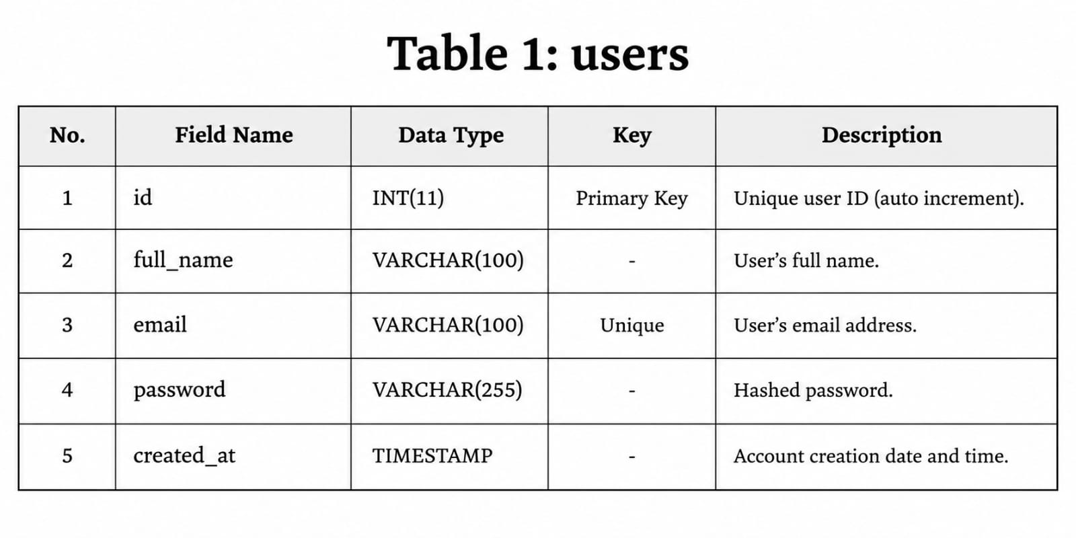

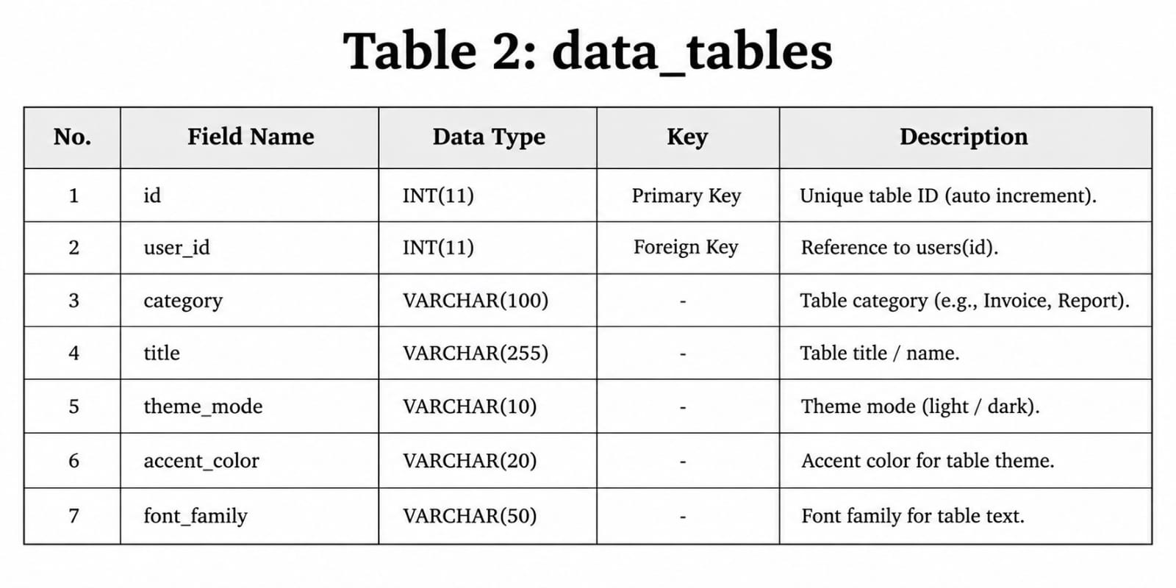

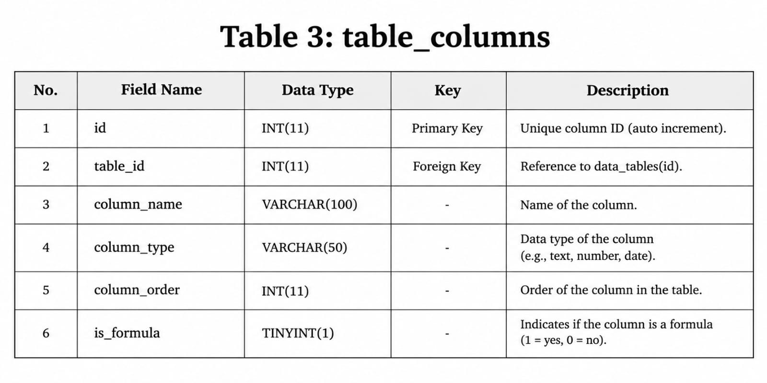

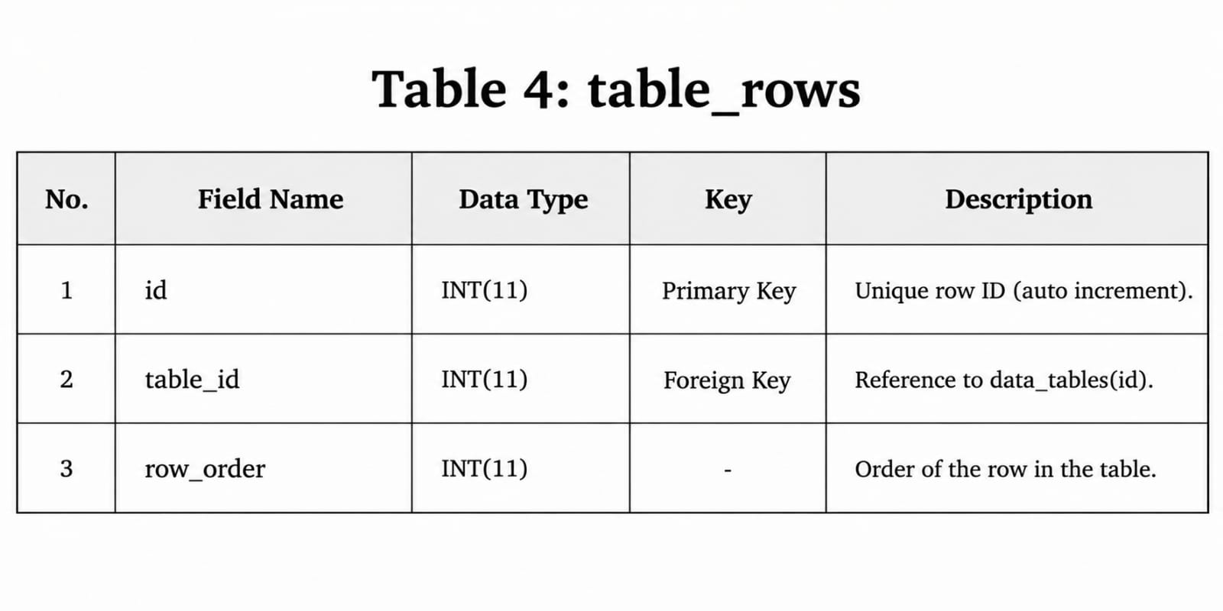

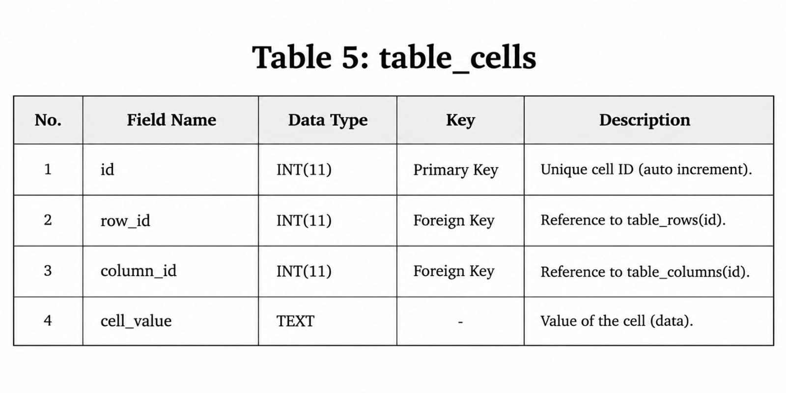

5.1 Key Fields
- users.id: primary key for account identity.
- data_tables.user_id: ownership relation.
- table_columns.table_id: parent table relation and column order.
- table_rows.table_id: parent table relation and row order.
- table_cells.row_id / column_id: intersection between a row and a column.

5.2 Relationship
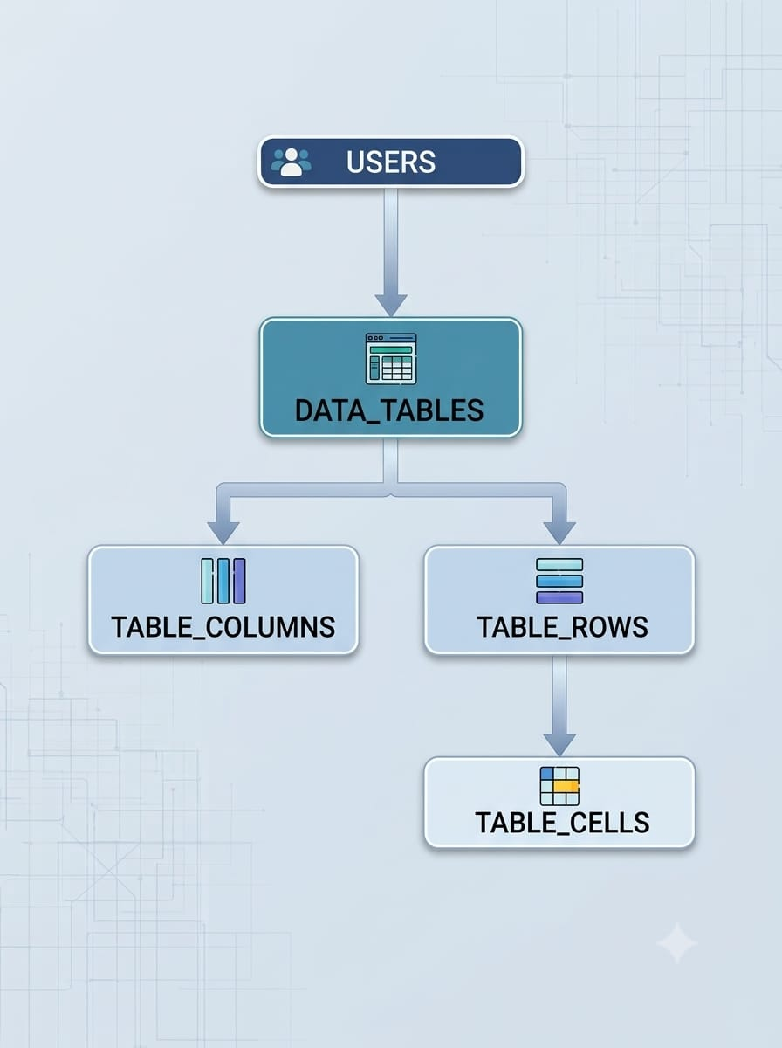

5.3 Advantages
- Multiple users and multiple tables per user.
- Dynamic columns and rows.
- Flexible cell storage.
- Table ownership.
- Cascading cleanup of dependent records.
- Foundation for future features.

6. DATA FLOW DIAGRAM — ADMIN & CLIENT

DFD Symbol
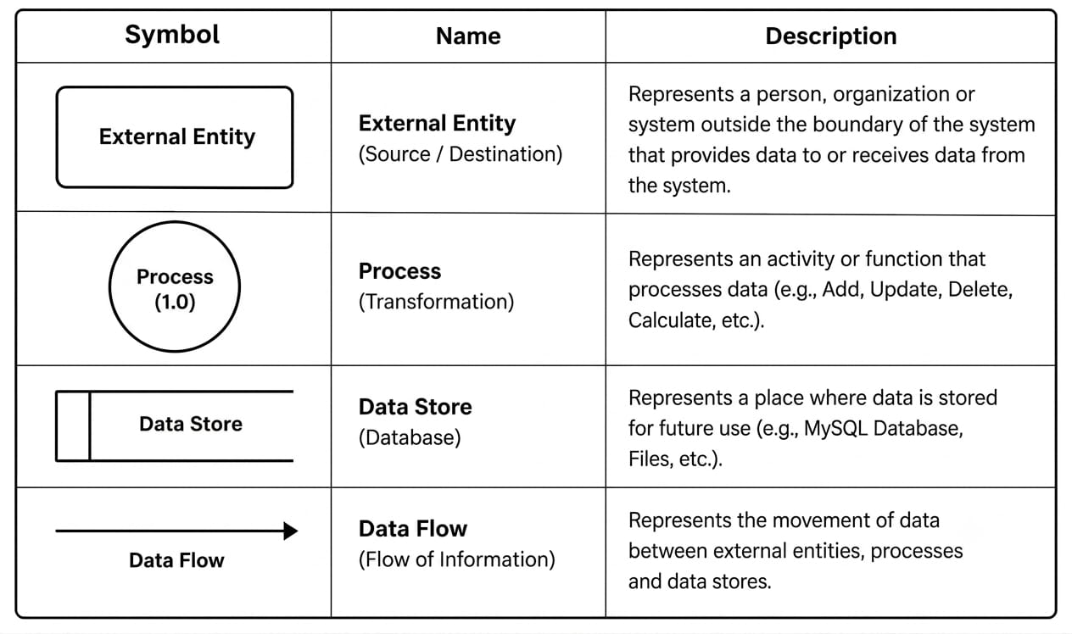

6.1 Level 0 DFD

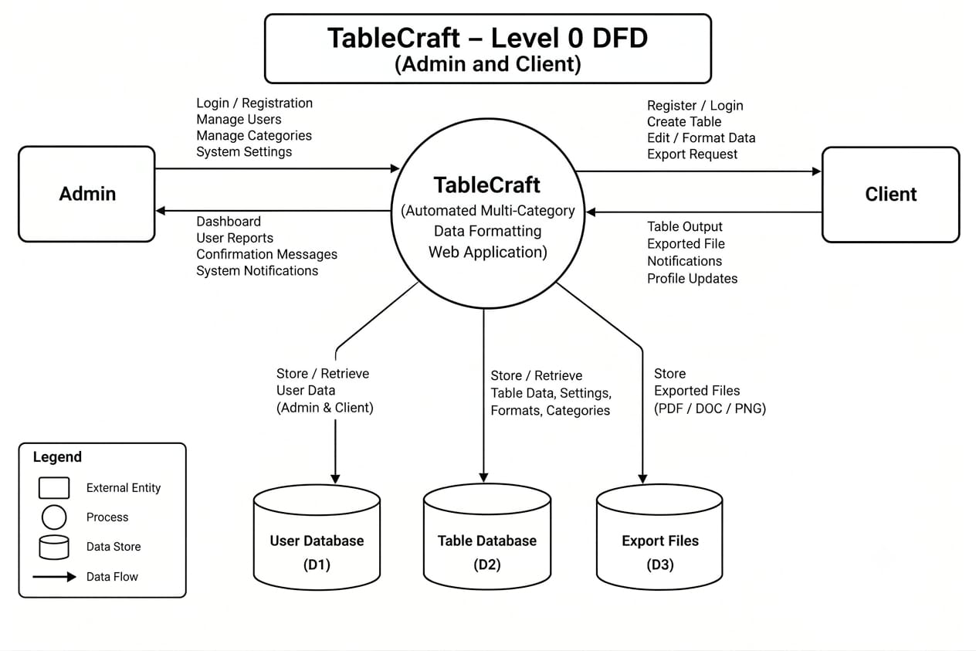

6.2 Level 1 DFD

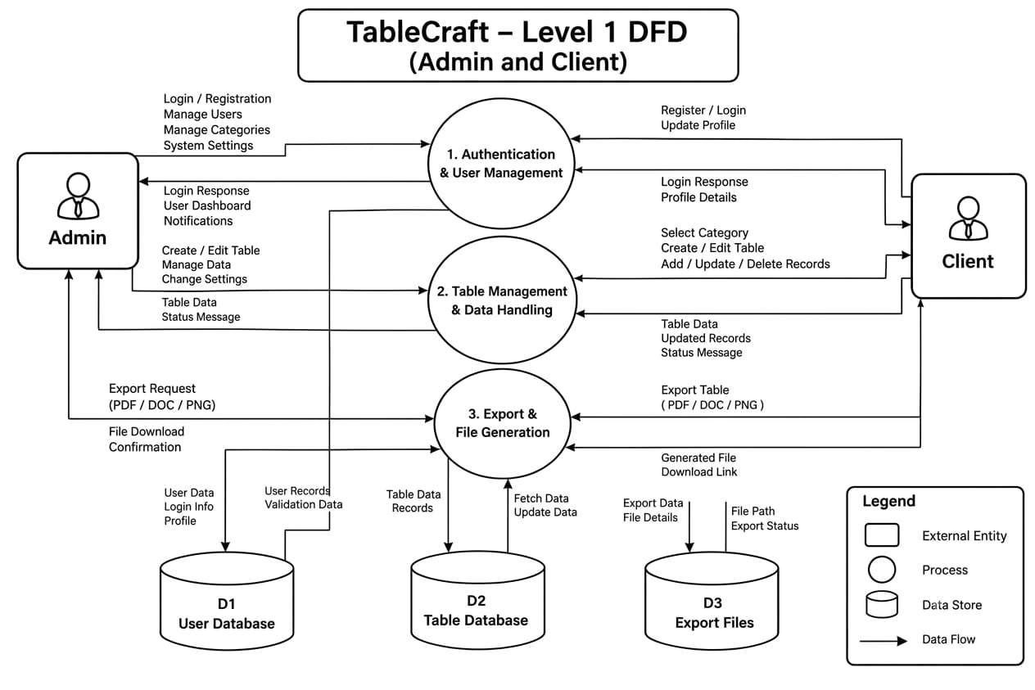

6.3 Level 2 DFD

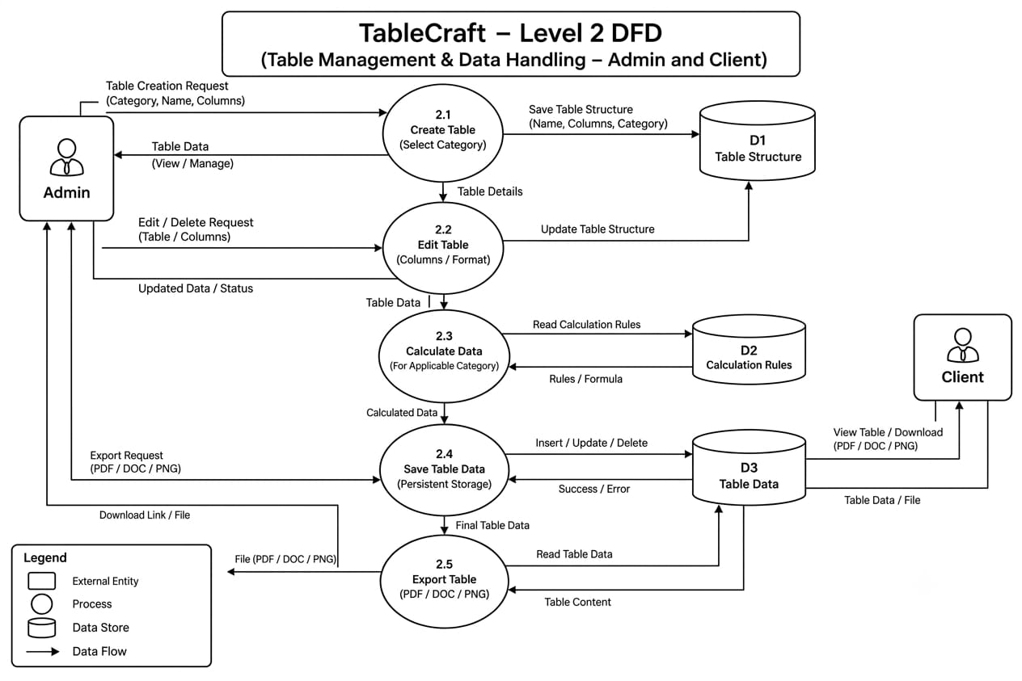

6.4 Timeline Chart
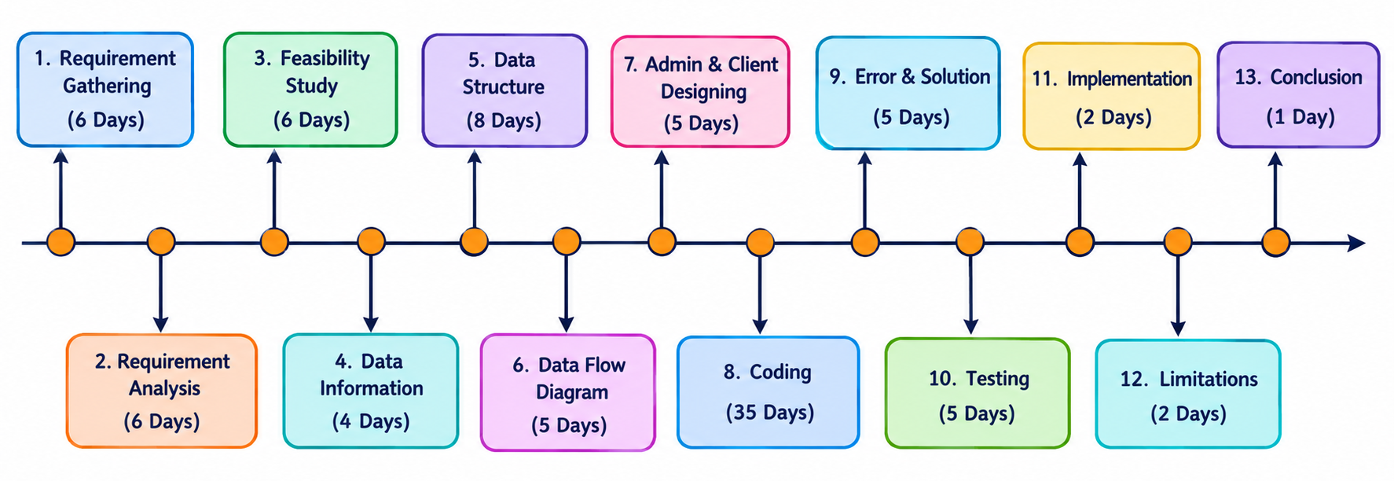

6.5 Bar Chart
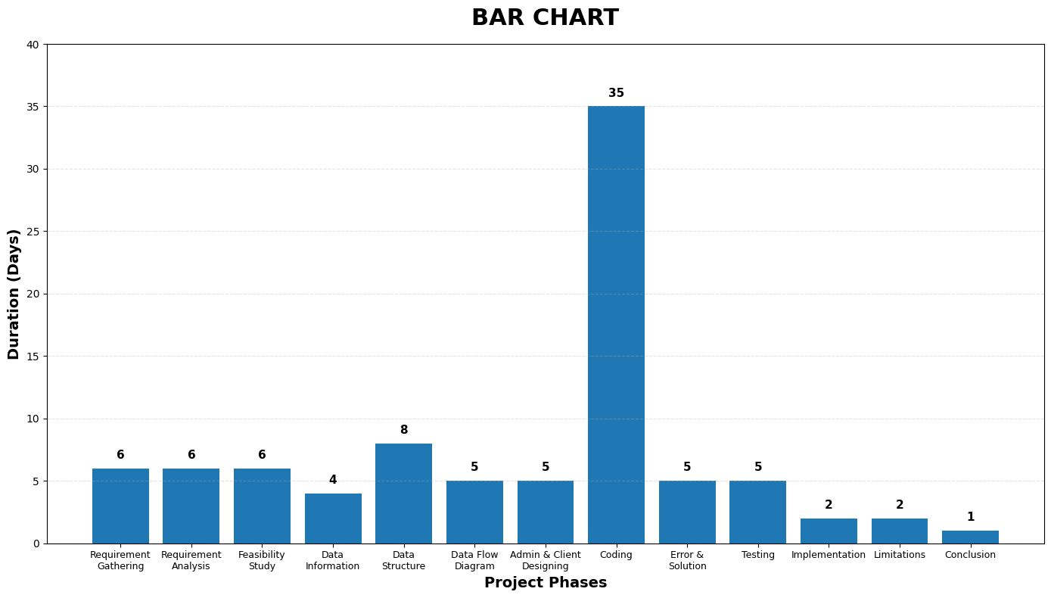

6.6 Phase wise Duration

Phase | Days
Requirement Gathering | 6
Requirement Analysis | 6
Feasibility Study | 6
Data Information | 4
Data Structure | 8
Data Flow Diagram: Admin & Client | 5
Designing: Admin & Client | 5
Coding | 35
Error & Solution | 5
Testing | 5
Implementation | 2
Limitations | 2
Conclusion | 1

7. DESIGNING — ADMIN & CLIENT

7.1 Design Objective
The design uses a professional blue, black and white visual theme. The interface emphasizes simplicity, visual hierarchy, responsive behavior and consistent controls.

Color | Hex | Use
Navy | #080E53 | Branding/headings
Blue | #1F50FF | Buttons/links/accents
Light | #F7F7F7 | Backgrounds
White | #FFFFFF | Cards/forms/table surfaces
Black | #111111 | Body text

7.2 Typography
Figtree is used as the main interface font with different weights for headings, navigation, buttons and body text.

7.3 Responsive Design
- Bootstrap grid
- Responsive cards
- Responsive navigation
- Responsive forms
- Responsive tables
- Mobile-friendly spacing

7.4 Navigation
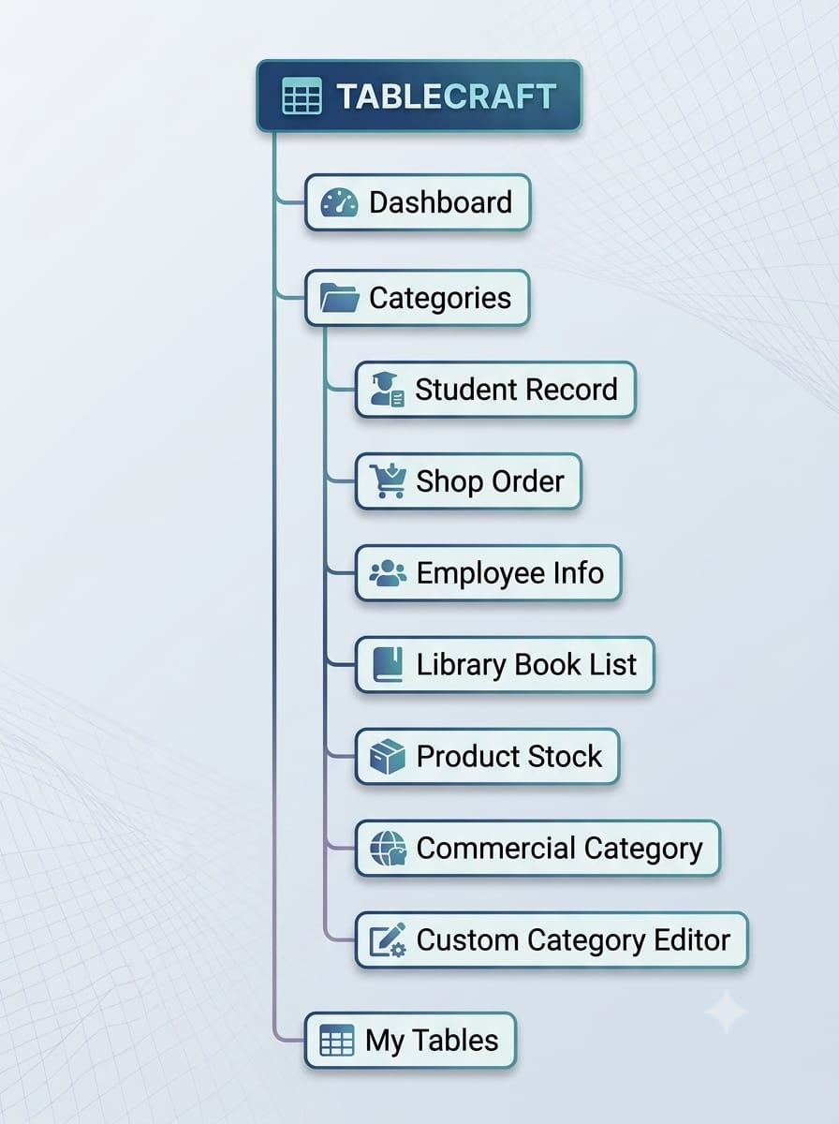

7.5 Authentication and Dashboard
The authentication interface provides clean forms, validation feedback and password visibility control. The dashboard provides category cards, quick actions, recent tables, navigation and animated interface elements.

8. CODING

8.1 Database Connection
config/db.php centralizes the MySQL connection and enables UTF-8 support through utf8mb4.

- config/db.php
<?php
/**
* TableCraft - Database Connection
* WampServer default credentials are used below.
* Change DB_USER / DB_PASS only if you customised your MySQL root account.
*/

define('DB_HOST', 'localhost');
define('DB_USER', 'root');
define('DB_PASS', '');
define('DB_NAME', 'tablecraft');

// Base URL of the project as seen in the browser, e.g. http://localhost/tablecraft
// Used to build absolute links in emails / redirects if ever needed.
define('BASE_URL', '/tablecraft');

$conn = mysqli_connect(DB_HOST, DB_USER, DB_PASS, DB_NAME);

if (!$conn) {
die('<div style="font-family:Arial;padding:40px;color:#080E53">
<h2>Database connection failed</h2>
<p>' . htmlspecialchars(mysqli_connect_error()) . '</p>
<p>Make sure WampServer is running (icon is green) and that you have
imported <code>database/tablecraft.sql</code> in phpMyAdmin.</p>
</div>');
}

mysqli_set_charset($conn, 'utf8mb4');

// Start session on every page that includes this file
if (session_status() === PHP_SESSION_NONE) {
session_start();
}

8.2 Authentication
Registration validates account details and stores passwords using password_hash(). Login verifies passwords using password_verify().
LOGIN
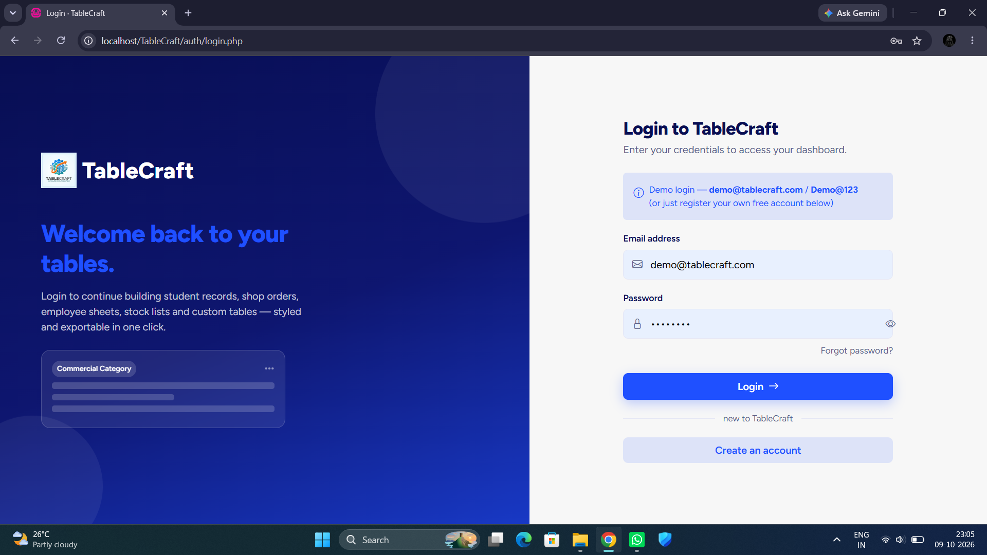

- auth/login.php
<?php
require_once __DIR__ . '/../config/db.php';
if (isset($_SESSION['user_id'])) { header('Location: ../dashboard.php'); exit; }

$errors = [];
$oldEmail = '';

if ($_SERVER['REQUEST_METHOD'] === 'POST') {
$email = trim($_POST['email'] ?? '');
$password = $_POST['password'] ?? '';
$oldEmail = $email;

if ($email === '' || $password === '') {
$errors[] = 'Please enter both email and password.';
} else {
$stmt = mysqli_prepare($conn, 'SELECT id, full_name, email, password, avatar_color FROM users WHERE email = ?');
mysqli_stmt_bind_param($stmt, 's', $email);
mysqli_stmt_execute($stmt);
$result = mysqli_stmt_get_result($stmt);
$user = mysqli_fetch_assoc($result);
mysqli_stmt_close($stmt);

if ($user && password_verify($password, $user['password'])) {
$_SESSION['user_id'] = $user['id'];
$_SESSION['user_name'] = $user['full_name'];
$_SESSION['user_email'] = $user['email'];
$_SESSION['avatar_color'] = $user['avatar_color'];
header('Location: ../dashboard.php');
exit;
} else {
$errors[] = 'Incorrect email or password. Please try again.';
}
}
}
?><!DOCTYPE html>
<html lang="en">
<head>
<meta charset="UTF-8">
<meta name="viewport" content="width=device-width, initial-scale=1.0">
<title>Login · TableCraft</title>
<script>(function(){ var t = localStorage.getItem('tc_theme') || 'bright'; document.documentElement.setAttribute('data-theme', t); })();</script>
<link rel="preconnect" href="https://fonts.googleapis.com">
<link href="https://fonts.googleapis.com/css2?family=Figtree:ital,wght@0,300;0,400;0,500;0,600;0,700;0,800;1,400&display=swap" rel="stylesheet">
<link href="https://cdn.jsdelivr.net/npm/bootstrap@5.3.3/dist/css/bootstrap.min.css" rel="stylesheet">
<link href="https://cdn.jsdelivr.net/npm/bootstrap-icons@1.11.3/font/bootstrap-icons.css" rel="stylesheet">
<link href="../assets/css/style.css" rel="stylesheet">
<style>
img {
height: 55px;
width: 55px;
}
h1 {
color: #f9fafa;
}
label {
font-size: 35px;
color: #36b1e6;
}
</style>
</head>
<body>

<div class="auth-wrap">
<div class="auth-visual d-none d-lg-flex">
<a href="../index.php" class="tc-logo mb-5" style="color:#fff">
<img src="../assets/media/logo.jpeg" alt="TableCraft Logo">
<label> TableCraft </label>
</a>
<h1 class="fw-800 mb-3" style="font-size:2.4rem;max-width:460px;">Welcome back to your tables.</h1>
<p class="mb-4" style="color:rgba(255,255,255,.75);max-width:420px;">Login to continue building student records, shop orders, employee sheets, stock lists and custom tables — styled and exportable in one click.</p>

<div class="auth-mock-table" style="max-width:380px;">
<div class="d-flex justify-content-between mb-2">
<span class="badge-category" style="background:rgba(255,255,255,.15);color:#fff;">Commercial Category</span>
<i class="bi bi-three-dots text-white-50"></i>
</div>
<div class="row-line"></div>
<div class="row-line short"></div>
<div class="row-line"></div>
</div>
</div>

<div class="auth-form-side">
<div class="auth-card">
<div class="text-center mb-4 d-lg-none">
<a href="../index.php" class="tc-logo justify-content-center"><span class="tc-logo-mark">TC</span> TableCraft</a>
</div>

<h3 class="fw-800 mb-1">Login to TableCraft</h3>
<p class="text-soft mb-4">Enter your credentials to access your dashboard.</p>

<?php if (!empty($errors)): ?>
<div class="alert alert-danger" role="alert">
<?php foreach ($errors as $err): ?><div><i class="bi bi-exclamation-circle me-1"></i><?= htmlspecialchars($err) ?></div><?php endforeach; ?>
</div>
<?php endif; ?>

<div class="alert alert-primary d-flex align-items-start gap-2" style="background:var(--blue-soft);border:none;color:var(--accent);">
<i class="bi bi-info-circle mt-1"></i>
<div class="small">Demo login — <strong>demo@tablecraft.com</strong> / <strong>Demo@123</strong><br>(or just register your own free account below)</div>
</div>

<form method="post" novalidate>
<div class="mb-3">
<label class="form-label">Email address</label>
<div class="input-icon-group">
<i class="bi bi-envelope"></i>
<input type="email" name="email" class="form-control" placeholder="you@example.com" value="<?= htmlspecialchars($oldEmail) ?>" required>
</div>
</div>
<div class="mb-2">
<label class="form-label">Password</label>
<div class="input-icon-group">
<i class="bi bi-lock"></i>
<input type="password" name="password" class="form-control" placeholder="Your password" required>
<button type="button" class="toggle-eye"></i></button>
</div>
</div>
<div class="d-flex justify-content-end mb-4">
<a href="#" class="small text-soft" tabindex="-1">Forgot password?</a>
</div>

<button type="submit" class="btn btn-primary w-100 py-2">Login <i class="bi bi-arrow-right ms-1"></i></button>
</form>

<div class="divider-text">new to TableCraft</div>
<a href="register.php" class="btn btn-soft w-100 py-2">Create an account</a>
</div>
</div>
</div>
<script src="../assets/js/theme.js"></script>
<script src="../assets/js/main.js"></script>
</body>
</html>

REGISTRATION PAGE
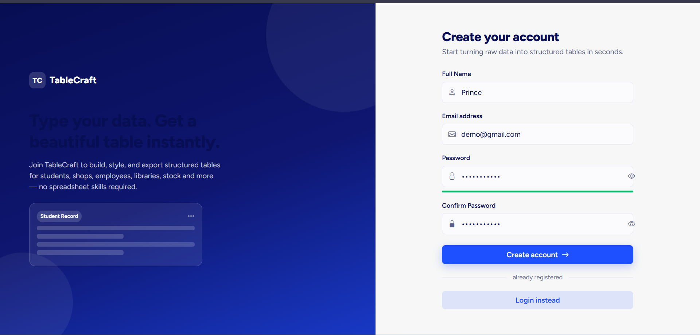
- auth/register.php
<?php
require_once __DIR__ . '/../config/db.php';

if (isset($_SESSION['user_id'])) { header('Location: ../dashboard.php'); exit; }

$errors = [];
$old = ['full_name' => '', 'email' => ''];

if ($_SERVER['REQUEST_METHOD'] === 'POST') {
$full_name = trim($_POST['full_name'] ?? '');
$email = trim($_POST['email'] ?? '');
$password = $_POST['password'] ?? '';
$confirm = $_POST['confirm_password'] ?? '';
$old = ['full_name' => $full_name, 'email' => $email];

if ($full_name === '' || strlen($full_name) < 2) $errors[] = 'Please enter your full name.';
if (!filter_var($email, FILTER_VALIDATE_EMAIL)) $errors[] = 'Please enter a valid email address.';
if (strlen($password) < 6) $errors[] = 'Password must be at least 6 characters long.';
if ($password !== $confirm) $errors[] = 'Passwords do not match.';

if (empty($errors)) {
$stmt = mysqli_prepare($conn, 'SELECT id FROM users WHERE email = ?');
mysqli_stmt_bind_param($stmt, 's', $email);
mysqli_stmt_execute($stmt);
mysqli_stmt_store_result($stmt);
if (mysqli_stmt_num_rows($stmt) > 0) {
$errors[] = 'An account with this email already exists. Please login instead.';
}
mysqli_stmt_close($stmt);
}

if (empty($errors)) {
$palette = ['#1F50FF', '#080E53', '#4B74FF', '#17B26A', '#F5A524'];
$avatarColor = $palette[array_rand($palette)];
$hash = password_hash($password, PASSWORD_BCRYPT);

$stmt = mysqli_prepare($conn, 'INSERT INTO users (full_name, email, password, avatar_color) VALUES (?, ?, ?, ?)');
mysqli_stmt_bind_param($stmt, 'ssss', $full_name, $email, $hash, $avatarColor);

if (mysqli_stmt_execute($stmt)) {
$_SESSION['user_id'] = mysqli_insert_id($conn);
$_SESSION['user_name'] = $full_name;
$_SESSION['user_email'] = $email;
$_SESSION['avatar_color'] = $avatarColor;
header('Location: ../dashboard.php');
exit;
} else {
$errors[] = 'Something went wrong while creating your account. Please try again.';
}
mysqli_stmt_close($stmt);
}
}
?><!DOCTYPE html>
<html lang="en">
<head>
<meta charset="UTF-8">
<meta name="viewport" content="width=device-width, initial-scale=1.0">
<title>Register · TableCraft</title>
<script>(function(){ var t = localStorage.getItem('tc_theme') || 'bright'; document.documentElement.setAttribute('data-theme', t); })();</script>
<link rel="preconnect" href="https://fonts.googleapis.com">
<link href="https://fonts.googleapis.com/css2?family=Figtree:ital,wght@0,300;0,400;0,500;0,600;0,700;0,800;1,400&display=swap" rel="stylesheet">
<link href="https://cdn.jsdelivr.net/npm/bootstrap@5.3.3/dist/css/bootstrap.min.css" rel="stylesheet">
<link href="https://cdn.jsdelivr.net/npm/bootstrap-icons@1.11.3/font/bootstrap-icons.css" rel="stylesheet">
<link href="../assets/css/style.css" rel="stylesheet">
<style>
img {
height: 55px;
width: 55px;
}
label {
font-size: 35px;
color: #36b1e6;
}
h1 {
color: #f9fafa;
}
</style>
</head>
<body>

<div class="auth-wrap">
<div class="auth-visual d-none d-lg-flex">
<a href="../index.php" class="tc-logo mb-5" style="color:#fff">
<img src="../assets/media/logo.jpeg" alt="TableCraft Logo">
<label> TableCraft </label>
</a>
<h1 class="fw-800 mb-3" style="font-size:2.4rem;max-width:460px;">Type your data. Get a beautiful table instantly.</h1>
<p class="mb-4" style="color:rgba(255,255,255,.75);max-width:420px;">Join TableCraft to build, style, and export structured tables for students, shops, employees, libraries, stock and more — no spreadsheet skills required.</p>

<div class="auth-mock-table" style="max-width:380px;">
<div class="d-flex justify-content-between mb-2">
<span class="badge-category" style="background:rgba(255,255,255,.15);color:#fff;">Student Record</span>
<i class="bi bi-three-dots text-white-50"></i>
</div>
<div class="row-line"></div>
<div class="row-line short"></div>
<div class="row-line"></div>
<div class="row-line short"></div>
</div>
</div>

<div class="auth-form-side">
<div class="auth-card">
<div class="text-center mb-4 d-lg-none">
<a href="../index.php" class="tc-logo justify-content-center"><span class="tc-logo-mark">TC</span> TableCraft</a>
</div>

<h3 class="fw-800 mb-1">Create your account</h3>
<p class="text-soft mb-4">Start turning raw data into structured tables in seconds.</p>

<?php if (!empty($errors)): ?>
<div class="alert alert-danger" role="alert">
<?php foreach ($errors as $err): ?><div><i class="bi bi-exclamation-circle me-1"></i><?= htmlspecialchars($err) ?></div><?php endforeach; ?>
</div>
<?php endif; ?>

<form method="post" novalidate>
<div class="mb-3">
<label class="form-label">Full Name</label>
<div class="input-icon-group">
<i class="bi bi-person"></i>
<input type="text" name="full_name" class="form-control" placeholder="Thumar Paras" value="<?= htmlspecialchars($old['full_name']) ?>" required>
</div>
</div>
<div class="mb-3">
<label class="form-label">Email address</label>
<div class="input-icon-group">
<i class="bi bi-envelope"></i>
<input type="email" name="email" class="form-control" placeholder="you@example.com" value="<?= htmlspecialchars($old['email']) ?>" required>
</div>
</div>
<div class="mb-2">
<label class="form-label">Password</label>
<div class="input-icon-group">
<i class="bi bi-lock"></i>
<input type="password" id="reg_password" name="password" class="form-control" placeholder="At least 6 characters" required>
<button type="button" class="toggle-eye"><i class="bi bi-eye"></i></button>
</div>
</div>
<div class="mb-3">
<div style="height:4px;border-radius:4px;background:var(--border);overflow:hidden;">
<div id="pw_strength_bar" style="height:100%;width:0;transition:width .2s ease;"></div>
</div>
</div>
<div class="mb-4">
<label class="form-label">Confirm Password</label>
<div class="input-icon-group">
<i class="bi bi-lock-fill"></i>
<input type="password" name="confirm_password" class="form-control" placeholder="Re-enter password" required>
<button type="button" class="toggle-eye"><i class="bi bi-eye"></i></button>
</div>
</div>

<button type="submit" class="btn btn-primary w-100 py-2">Create account <i class="bi bi-arrow-right ms-1"></i></button>
</form>

<div class="divider-text">already registered</div>
<a href="login.php" class="btn btn-soft w-100 py-2">Login instead</a>
</div>
</div>
</div>

<script src="../assets/js/theme.js"></script>
<script src="../assets/js/main.js"></script>
</body>
</html>

- auth/logout.php
<?php
require_once __DIR__ . '/../config/db.php';
$_SESSION = [];
session_unset();
session_destroy();
header('Location: login.php');
exit;

8.3 Sessions
The session stores user identity information and protects private pages through auth_check.php.

- includes/auth_check.php
<?php
/**
* Include this AFTER config/db.php on every protected page.
* Redirects to the login page if no user is logged in.
*/
if (!isset($_SESSION['user_id'])) {
header('Location: ' . (strpos($_SERVER['PHP_SELF'], '/categories/') !== false || strpos($_SERVER['PHP_SELF'], '/api/') !== false ? '../auth/login.php' : 'auth/login.php'));
exit;
}

8.4 Category System
includes/category_defaults.php centralizes category labels, icons, descriptions, commercial flags and default columns.
DEFAULT CATEGORY
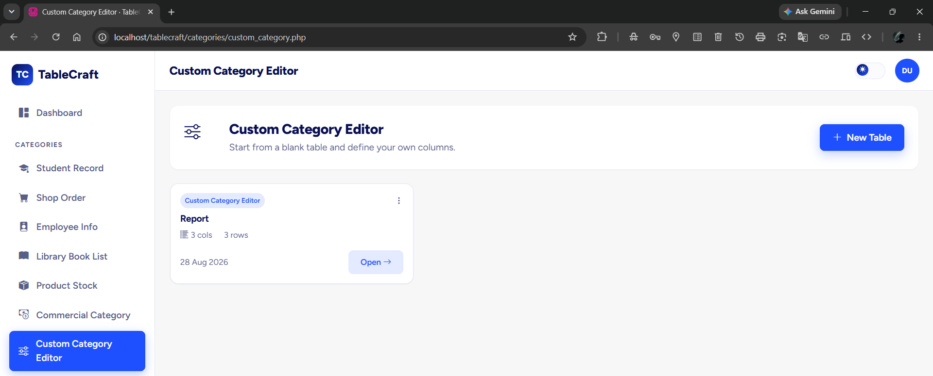

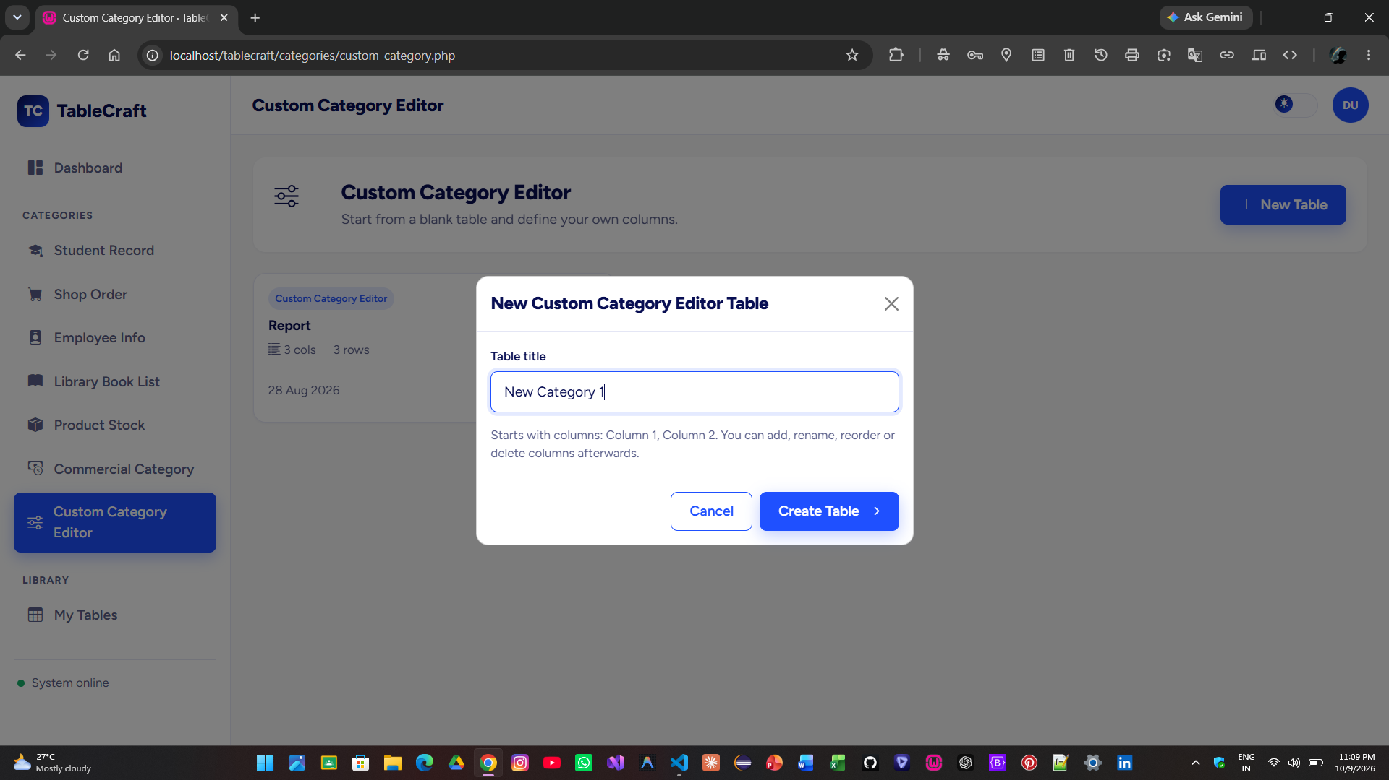

- includes/category_defaults.php
<?php
/**
* Central definition of every category: display info + default columns
* used when a brand new table is created (new_table.php).
* column_type: text | number | date | currency
*/
function tc_category_map() {
return [
'student_record' => [
'label' => 'Student Record',
'icon' => 'bi-mortarboard-fill',
'desc' => 'Roll numbers, names, class, subjects, marks and attendance.',
'is_commercial' => 0,
'columns' => [
['name' => 'Roll No', 'type' => 'number'],
['name' => 'Student Name', 'type' => 'text'],
['name' => 'Class', 'type' => 'text'],
['name' => 'Subject', 'type' => 'text'],
['name' => 'Marks', 'type' => 'number'],
['name' => 'Attendance %', 'type' => 'number'],
],
],
'shop_order' => [
'label' => 'Shop Order',
'icon' => 'bi-cart-fill',
'desc' => 'Customer orders with quantity, price and auto-calculated total.',
'is_commercial' => 0,
'columns' => [
['name' => 'Order ID', 'type' => 'text'],
['name' => 'Customer Name', 'type' => 'text'],
['name' => 'Product', 'type' => 'text'],
['name' => 'Quantity', 'type' => 'number'],
['name' => 'Price', 'type' => 'currency'],
['name' => 'Total', 'type' => 'currency', 'formula' => 1],
['name' => 'Order Date', 'type' => 'date'],
],
],
'employee_info' => [
'label' => 'Employee Info',
'icon' => 'bi-person-badge-fill',
'desc' => 'Employee directory with department, designation and salary.',
'is_commercial' => 0,
'columns' => [
['name' => 'Employee ID', 'type' => 'text'],
['name' => 'Full Name', 'type' => 'text'],
['name' => 'Department', 'type' => 'text'],
['name' => 'Designation', 'type' => 'text'],
['name' => 'Joining Date', 'type' => 'date'],
['name' => 'Salary', 'type' => 'currency'],
],
],
'library_books' => [
'label' => 'Library Book List',
'icon' => 'bi-book-fill',
'desc' => 'Track book issues, returns and availability status.',
'is_commercial' => 0,
'columns' => [
['name' => 'Book ID', 'type' => 'text'],
['name' => 'Title', 'type' => 'text'],
['name' => 'Author', 'type' => 'text'],
['name' => 'Category', 'type' => 'text'],
['name' => 'Issue Date', 'type' => 'date'],
['name' => 'Return Date', 'type' => 'date'],
['name' => 'Status', 'type' => 'text'],
],
],
'product_stock' => [
'label' => 'Product Stock',
'icon' => 'bi-box-seam-fill',
'desc' => 'Inventory levels with auto-calculated stock value.',
'is_commercial' => 0,
'columns' => [
['name' => 'Product ID', 'type' => 'text'],
['name' => 'Product Name', 'type' => 'text'],
['name' => 'Category', 'type' => 'text'],
['name' => 'Quantity', 'type' => 'number'],
['name' => 'Price', 'type' => 'currency'],
['name' => 'Stock Value', 'type' => 'currency', 'formula' => 1],
],
],
'commercial' => [
'label' => 'Commercial Category',
'icon' => 'bi-cash-coin',
'desc' => 'Invoices / billing sheets with quantity × price − discount% math.',
'is_commercial' => 1,
'columns' => [
['name' => 'Item', 'type' => 'text'],
['name' => 'Quantity', 'type' => 'number'],
['name' => 'Price', 'type' => 'currency'],
['name' => 'Discount %', 'type' => 'number'],
['name' => 'Total', 'type' => 'currency', 'formula' => 1],
],
],
'custom' => [
'label' => 'Custom Category Editor',
'icon' => 'bi-sliders',
'desc' => 'Start from a blank table and define your own columns.',
'is_commercial' => 0,
'columns' => [
['name' => 'Column 1', 'type' => 'text'],
['name' => 'Column 2', 'type' => 'text'],
],
],
];
}

- includes/category_page_body.php
<?php
/**
* Shared body for every /categories/*.php page.
* Expects $categoryKey to be set before include.
* Must be included AFTER header.php.
*/
require_once __DIR__ . '/category_defaults.php';
$map = tc_category_map();
$cat = $map[$categoryKey];
$userId = $_SESSION['user_id'];

$stmt = mysqli_prepare($conn, 'SELECT id, title, theme_mode, accent_color, updated_at,
(SELECT COUNT(*) FROM table_rows WHERE table_id = data_tables.id) AS row_count,
(SELECT COUNT(*) FROM table_columns WHERE table_id = data_tables.id) AS col_count
FROM data_tables WHERE user_id = ? AND category = ? ORDER BY updated_at DESC');
mysqli_stmt_bind_param($stmt, 'is', $userId, $categoryKey);
mysqli_stmt_execute($stmt);
$tables = mysqli_fetch_all(mysqli_stmt_get_result($stmt), MYSQLI_ASSOC);
mysqli_stmt_close($stmt);
?>

<div class="tc-card stagger-item p-4 mb-4" style="border:none; background:var(--surface);">
<div class="d-flex flex-wrap align-items-center gap-3">
<div class="icon-badge" style="width:60px;height:60px;font-size:1.7rem;margin-bottom:0;"><i class="bi <?= $cat['icon'] ?>"></i></div>
<div class="flex-grow-1">
<h4 class="fw-800 mb-1"><?= htmlspecialchars($cat['label']) ?></h4>
<p class="text-soft mb-0"><?= htmlspecialchars($cat['desc']) ?></p>
</div>
<button class="btn btn-primary" data-bs-toggle="modal" data-bs-target="#newTableModal"><i class="bi bi-plus-lg me-1"></i> New Table</button>
</div>
</div>

<?php if (empty($tables)): ?>
<div class="tc-table-wrap">
<div class="empty-state">
<i class="bi <?= $cat['icon'] ?>"></i>
<p class="fw-600 mb-1" style="color:var(--text)">No <?= htmlspecialchars(strtolower($cat['label'])) ?> tables yet</p>
<p class="small mb-3">Default columns: <?= htmlspecialchars(implode(', ', array_map(function($c){ return $c['name']; }, $cat['columns']))) ?></p>
<button class="btn btn-primary" data-bs-toggle="modal" data-bs-target="#newTableModal"><i class="bi bi-plus-lg me-1"></i> Create your first table</button>
</div>
</div>
<?php else: ?>
<div class="row g-3">
<?php $i = 0; foreach ($tables as $t): $i++; ?>
<div class="col-md-6 col-xl-4">
<div class="tc-card tc-elevate stagger-item p-3" style="animation-delay:<?= $i * 50 ?>ms">
<div class="d-flex justify-content-between align-items-start mb-2">
<span class="badge-category"><?= htmlspecialchars($cat['label']) ?></span>
<div class="dropdown">
<button class="btn btn-sm btn-link text-soft p-0" data-bs-toggle="dropdown"><i class="bi bi-three-dots-vertical"></i></button>
<ul class="dropdown-menu dropdown-menu-end">
<li><a class="dropdown-item" href="../table_view.php?id=<?= $t['id'] ?>"><i class="bi bi-pencil-square me-2"></i>Open &amp; Edit</a></li>
<li><a class="dropdown-item text-danger del-table-btn" href="#" data-id="<?= $t['id'] ?>" data-name="<?= htmlspecialchars($t['title']) ?>"><i class="bi bi-trash me-2"></i>Delete</a></li>
</ul>
</div>
</div>
<h6 class="fw-700 mb-2"><?= htmlspecialchars($t['title']) ?></h6>
<div class="d-flex gap-3 text-soft small mb-3">
<span><i class="bi bi-list-columns-reverse me-1"></i><?= (int)$t['col_count'] ?> cols</span>
<span><i class="bi bi-rows me-1"></i><?= (int)$t['row_count'] ?> rows</span>
</div>
<div class="d-flex justify-content-between align-items-center">
<span class="text-soft small"><?= date('d M Y', strtotime($t['updated_at'])) ?></span>
<a href="../table_view.php?id=<?= $t['id'] ?>" class="btn btn-sm btn-soft">Open <i class="bi bi-arrow-right"></i></a>
</div>
</div>
</div>
<?php endforeach; ?>
</div>
<?php endif; ?>

<!-- New Table Modal -->
<div class="modal fade" id="newTableModal" tabindex="-1">
<div class="modal-dialog modal-dialog-centered">
<div class="modal-content" style="background:var(--surface); color:var(--text); border-radius:var(--radius-md);">
<form method="post" action="../new_table.php">
<div class="modal-header" style="border-color:var(--border)">
<h5 class="modal-title fw-800">New <?= htmlspecialchars($cat['label']) ?> Table</h5>
<button type="button" class="btn-close" data-bs-dismiss="modal"></button>
</div>
<div class="modal-body">
<input type="hidden" name="category" value="<?= htmlspecialchars($categoryKey) ?>">
<label class="form-label">Table title</label>
<input type="text" name="title" class="form-control" placeholder="e.g. <?= htmlspecialchars($cat['label']) ?> - <?= date('M Y') ?>">
<p class="text-soft small mt-3 mb-0">Starts with columns: <?= htmlspecialchars(implode(', ', array_map(function($c){ return $c['name']; }, $cat['columns']))) ?>. You can add, rename, reorder or delete columns afterwards.</p>
</div>
<div class="modal-footer" style="border-color:var(--border)">
<button type="button" class="btn btn-outline-primary" data-bs-dismiss="modal">Cancel</button>
<button type="submit" class="btn btn-primary">Create Table <i class="bi bi-arrow-right ms-1"></i></button>
</div>
</form>
</div>
</div>
</div>

<script>
document.addEventListener('click', function (e) {
const btn = e.target.closest('.del-table-btn');
if (!btn) return;
e.preventDefault();
if (!confirm('Delete "' + btn.dataset.name + '"? This cannot be undone.')) return;
fetch('../api/delete_table.php', {
method: 'POST', headers: { 'Content-Type': 'application/json' },
body: JSON.stringify({ table_id: btn.dataset.id })
}).then(r => r.json()).then(data => {
if (data.success) { location.reload(); } else { alert(data.message || 'Could not delete table'); }
});
});
</script>

8.5 Table Creation
new_table.php validates category and title, creates metadata, inserts default columns and creates initial rows.
CREATE TABLE
- new_table.php
<?php
require_once __DIR__ . '/config/db.php';
require_once __DIR__ . '/includes/auth_check.php';
require_once __DIR__ . '/includes/category_defaults.php';

if ($_SERVER['REQUEST_METHOD'] !== 'POST') { header('Location: dashboard.php'); exit; }

$category = $_POST['category'] ?? '';
$title = trim($_POST['title'] ?? '');
$map = tc_category_map();

if (!isset($map[$category])) { header('Location: dashboard.php'); exit; }
if ($title === '') { $title = $map[$category]['label'] . ' - ' . date('d M Y'); }

$userId = $_SESSION['user_id'];
$isCommercial = $map[$category]['is_commercial'];

mysqli_begin_transaction($conn);
try {
$stmt = mysqli_prepare($conn, 'INSERT INTO data_tables (user_id, category, title, is_commercial) VALUES (?, ?, ?, ?)');
mysqli_stmt_bind_param($stmt, 'issi', $userId, $category, $title, $isCommercial);
mysqli_stmt_execute($stmt);
$tableId = mysqli_insert_id($conn);
mysqli_stmt_close($stmt);

$order = 0;
$colStmt = mysqli_prepare($conn, 'INSERT INTO table_columns (table_id, column_name, column_type, column_order, is_formula) VALUES (?, ?, ?, ?, ?)');
foreach ($map[$category]['columns'] as $col) {
$formula = $col['formula'] ?? 0;
mysqli_stmt_bind_param($colStmt, 'issii', $tableId, $col['name'], $col['type'], $order, $formula);
mysqli_stmt_execute($colStmt);
$order++;
}
mysqli_stmt_close($colStmt);

// Start with 3 blank rows so the table isn't empty on first open
$rowStmt = mysqli_prepare($conn, 'INSERT INTO table_rows (table_id, row_order) VALUES (?, ?)');
for ($i = 0; $i < 3; $i++) {
mysqli_stmt_bind_param($rowStmt, 'ii', $tableId, $i);
mysqli_stmt_execute($rowStmt);
}
mysqli_stmt_close($rowStmt);

mysqli_commit($conn);
header('Location: table_view.php?id=' . $tableId);
exit;
} catch (Exception $e) {
mysqli_rollback($conn);
header('Location: dashboard.php?error=create_failed');
exit;
}

8.6 Table Editor
table_view.php loads table metadata and passes the initial state to the JavaScript table engine.
TABLE EDITOR
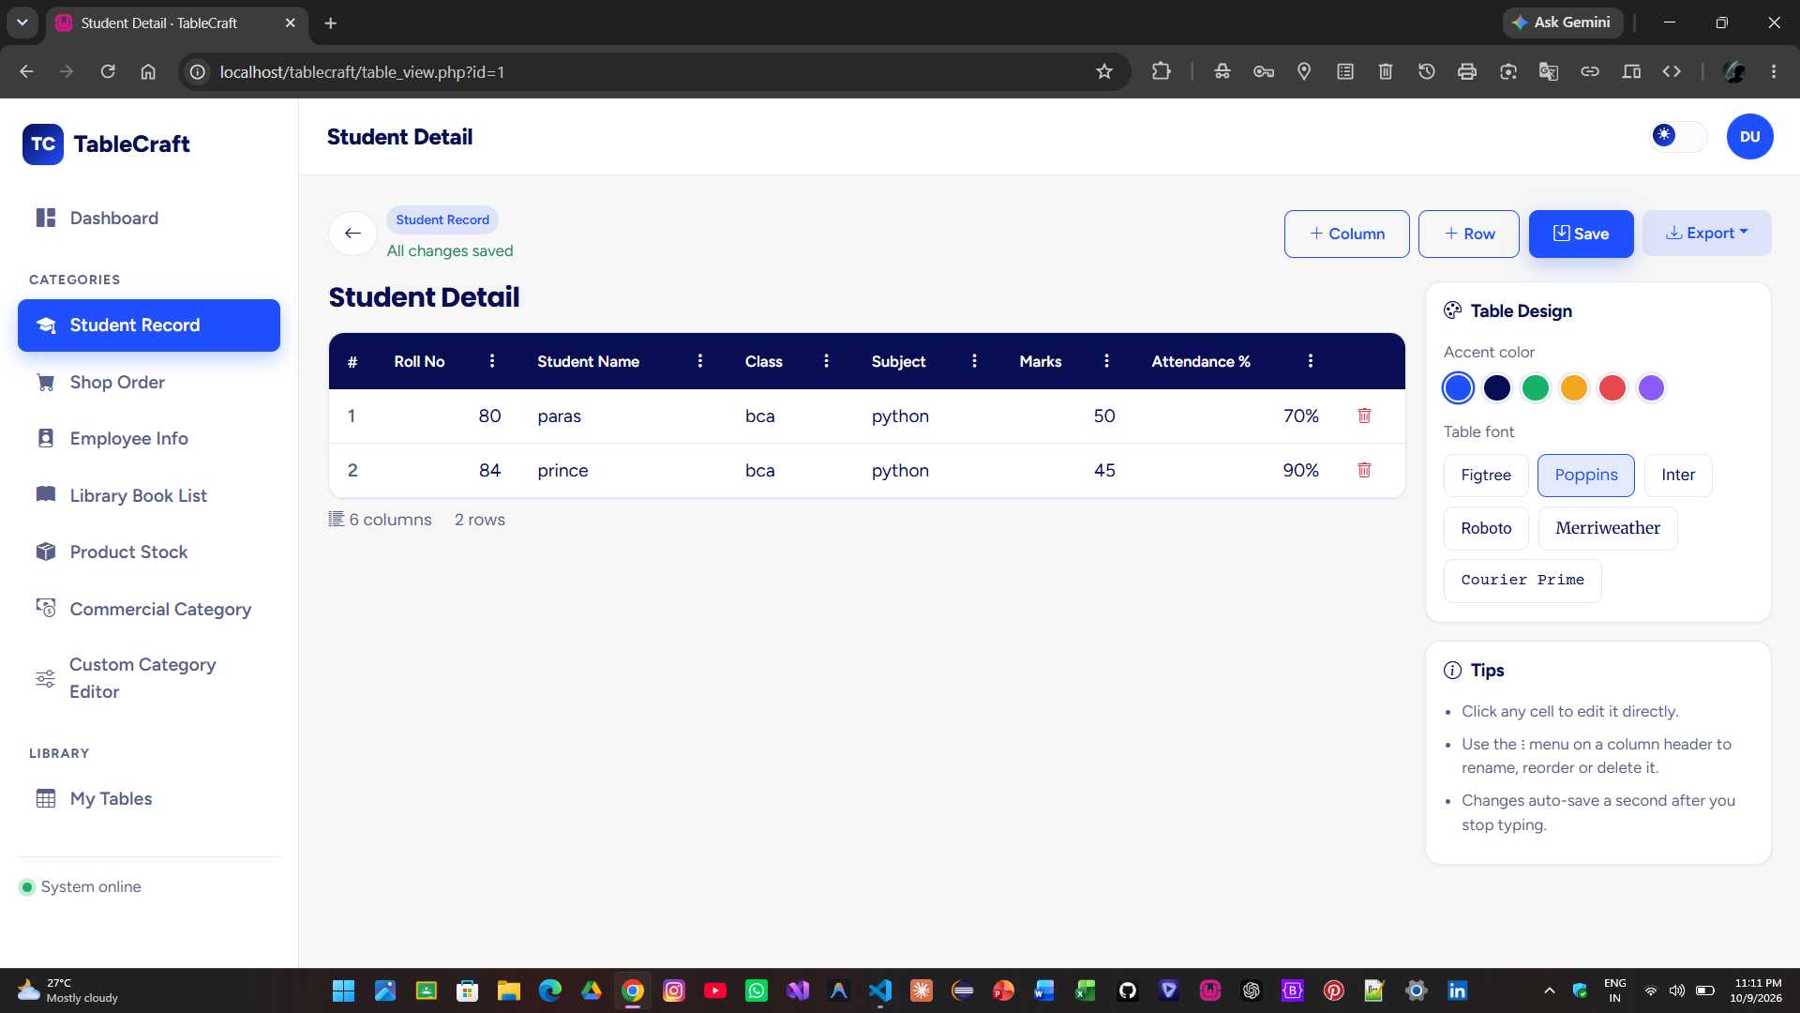

- table_view.php
<?php
require_once __DIR__ . '/config/db.php';
require_once __DIR__ . '/includes/auth_check.php';
require_once __DIR__ . '/includes/category_defaults.php';

$tableId = (int)($_GET['id'] ?? 0);
$userId = $_SESSION['user_id'];
$map = tc_category_map();

$stmt = mysqli_prepare($conn, 'SELECT * FROM data_tables WHERE id = ? AND user_id = ?');
mysqli_stmt_bind_param($stmt, 'ii', $tableId, $userId);
mysqli_stmt_execute($stmt);
$table = mysqli_fetch_assoc(mysqli_stmt_get_result($stmt));
mysqli_stmt_close($stmt);

if (!$table) {
header('Location: dashboard.php');
exit;
}

// Columns
$stmt = mysqli_prepare($conn, 'SELECT * FROM table_columns WHERE table_id = ? ORDER BY column_order ASC, id ASC');
mysqli_stmt_bind_param($stmt, 'i', $tableId);
mysqli_stmt_execute($stmt);
$columns = mysqli_fetch_all(mysqli_stmt_get_result($stmt), MYSQLI_ASSOC);
mysqli_stmt_close($stmt);

// Rows + cells
$stmt = mysqli_prepare($conn, 'SELECT id FROM table_rows WHERE table_id = ? ORDER BY row_order ASC, id ASC');
mysqli_stmt_bind_param($stmt, 'i', $tableId);
mysqli_stmt_execute($stmt);
$rowIds = array_column(mysqli_fetch_all(mysqli_stmt_get_result($stmt), MYSQLI_ASSOC), 'id');
mysqli_stmt_close($stmt);

$rows = [];
if (!empty($rowIds)) {
$placeholders = implode(',', array_fill(0, count($rowIds), '?'));
$types = str_repeat('i', count($rowIds));
$cellStmt = mysqli_prepare($conn, "SELECT row_id, column_id, cell_value FROM table_cells WHERE row_id IN ($placeholders)");
mysqli_stmt_bind_param($cellStmt, $types, ...$rowIds);
mysqli_stmt_execute($cellStmt);
$allCells = mysqli_fetch_all(mysqli_stmt_get_result($cellStmt), MYSQLI_ASSOC);
mysqli_stmt_close($cellStmt);

$cellsByRow = [];
foreach ($allCells as $c) { $cellsByRow[$c['row_id']][] = ['column_id' => (int)$c['column_id'], 'value' => $c['cell_value']]; }
foreach ($rowIds as $rid) { $rows[] = ['row_id' => $rid, 'cells' => $cellsByRow[$rid] ?? []]; }
}

$columnsJs = array_map(function ($c) {
return [
'id' => (int)$c['id'], 'column_name' => $c['column_name'], 'column_type' => $c['column_type'], 'is_formula' => (int)$c['is_formula'],
];
}, $columns);

$initData = [
'table_id' => (int)$table['id'],
'category' => $table['category'],
'title' => $table['title'],
'is_commercial' => (int)$table['is_commercial'],
'accent_color' => $table['accent_color'],
'font_family' => $table['font_family'],
'columns' => $columnsJs,
'rows' => $rows,
];
$catInfo = $map[$table['category']] ?? ['label' => ucwords(str_replace('_', ' ', $table['category']))];

$rootPath = '';
$pageTitle = $table['title'];
$activeNav = $table['category'] === 'custom' ? 'custom_category' : $table['category'];
require __DIR__ . '/includes/header.php';
?>

<div class="d-flex flex-wrap align-items-center justify-content-between gap-2 mb-3">
<div class="d-flex align-items-center gap-2">
<a href="dashboard.php" class="btn btn-icon"><i class="bi bi-arrow-left"></i></a>
<div>
<span class="badge-category mb-1 d-inline-block"><?= htmlspecialchars($catInfo['label']) ?></span>
<div id="tcSaveIndicator" class="text-success small">All changes saved</div>
</div>
</div>
<div class="d-flex flex-wrap gap-2">
<button class="btn btn-outline-primary btn-sm" id="addColBtn"><i class="bi bi-plus-lg me-1"></i>Column</button>
<button class="btn btn-outline-primary btn-sm" id="addRowBtn"><i class="bi bi-plus-lg me-1"></i>Row</button>
<button class="btn btn-primary btn-sm" id="manualSaveBtn"><i class="bi bi-save me-1"></i>Save</button>
<div class="dropdown">
<button class="btn btn-soft btn-sm dropdown-toggle" data-bs-toggle="dropdown"><i class="bi bi-download me-1"></i>Export</button>
<ul class="dropdown-menu dropdown-menu-end">
<li><a class="dropdown-item" href="#" id="exportPdfBtn"><i class="bi bi-file-earmark-pdf text-danger me-2"></i>PDF</a></li>
<li><a class="dropdown-item" href="#" id="exportDocBtn"><i class="bi bi-file-earmark-word text-primary me-2"></i>Word (DOC)</a></li>
<li><a class="dropdown-item" href="#" id="exportPngBtn"><i class="bi bi-file-earmark-image text-success me-2"></i>PNG Image</a></li>
</ul>
</div>
</div>
</div>

<div class="row g-3">
<div class="col-lg-9">
<div id="tcTableExportArea">
<h4 id="tcTitleInput" class="fw-800 mb-3" contenteditable="true" spellcheck="false"><?= htmlspecialchars($table['title']) ?></h4>
<div class="tc-table-wrap">
<div class="table-responsive">
<table class="table tc-table mb-0">
<thead id="tcThead"></thead>
<tbody id="tcTbody"></tbody>
<tfoot id="tcTfoot"></tfoot>
</table>
</div>
</div>
<div class="d-flex gap-3 text-soft small mt-2">
<span><i class="bi bi-list-columns-reverse me-1"></i><span id="tcColCount">0</span> columns</span>
<span><i class="bi bi-rows me-1"></i><span id="tcRowCount">0</span> rows</span>
</div>
</div>
</div>

<div class="col-lg-3">
<div class="tc-card p-3 mb-3">
<h6 class="fw-700 mb-3"><i class="bi bi-palette me-2"></i>Table Design</h6>
<p class="small text-soft mb-2">Accent color</p>
<div class="d-flex gap-2 flex-wrap mb-3">
<?php $colors = ['#1F50FF', '#080E53', '#17B26A', '#F5A524', '#E5484D', '#8B5CF6']; foreach ($colors as $c): ?>
<span class="swatch <?= $table['accent_color'] === $c ? 'active' : '' ?>" style="background:<?= $c ?>" data-color="<?= $c ?>"></span>
<?php endforeach; ?>
</div>
<p class="small text-soft mb-2">Table font</p>
<div class="d-flex gap-2 flex-wrap">
<?php $fonts = ['Figtree', 'Poppins', 'Inter', 'Roboto', 'Merriweather', 'Courier Prime']; foreach ($fonts as $f): ?>
<span class="font-thumb small <?= $table['font_family'] === $f ? 'active' : '' ?>" data-font="<?= $f ?>" style="font-family:'<?= $f ?>',sans-serif;"><?= $f ?></span>
<?php endforeach; ?>
</div>
</div>

<div class="tc-card p-3">
<h6 class="fw-700 mb-3"><i class="bi bi-info-circle me-2"></i>Tips</h6>
<ul class="small text-soft ps-3 mb-0">
<li class="mb-2">Click any cell to edit it directly.</li>
<li class="mb-2">Use the ⋮ menu on a column header to rename, reorder or delete it.</li>
<li class="mb-2">Changes auto-save a second after you stop typing.</li>
<?php if ($table['is_commercial'] || in_array($table['category'], ['shop_order', 'product_stock'])): ?>
<li>The <strong>Total</strong> column is calculated automatically.</li>
<?php endif; ?>
</ul>
</div>
</div>
</div>

<link href="https://fonts.googleapis.com/css2?family=Poppins:wght@400;600;700&family=Inter:wght@400;600;700&family=Roboto:wght@400;500;700&family=Merriweather:wght@400;700&family=Courier+Prime&display=swap" rel="stylesheet">

<script>const TC_INIT = <?= json_encode($initData, JSON_UNESCAPED_UNICODE) ?>;</script>
<script src="https://cdn.jsdelivr.net/npm/jspdf@2.5.1/dist/jspdf.umd.min.js"></script>
<script src="https://cdn.jsdelivr.net/npm/jspdf-autotable@3.8.2/dist/jspdf.plugin.autotable.min.js"></script>
<script src="https://cdn.jsdelivr.net/npm/html2canvas@1.4.1/dist/html2canvas.min.js"></script>
<script src="assets/js/table-builder.js"></script>
<script src="assets/js/export.js"></script>

<?php require __DIR__ . '/includes/footer.php'; ?>

▪ my_tables.php
<?php
require_once __DIR__ . '/config/db.php';
require_once __DIR__ . '/includes/auth_check.php';
require_once __DIR__ . '/includes/category_defaults.php';

$userId = $_SESSION['user_id'];
$map = tc_category_map();

$stmt = mysqli_prepare($conn, 'SELECT id, category, title, accent_color, updated_at,
(SELECT COUNT(*) FROM table_rows WHERE table_id = data_tables.id) AS row_count,
(SELECT COUNT(*) FROM table_columns WHERE table_id = data_tables.id) AS col_count
FROM data_tables WHERE user_id = ? ORDER BY updated_at DESC');
mysqli_stmt_bind_param($stmt, 'i', $userId);
mysqli_stmt_execute($stmt);
$tables = mysqli_fetch_all(mysqli_stmt_get_result($stmt), MYSQLI_ASSOC);
mysqli_stmt_close($stmt);

$pageTitle = 'My Tables';
$activeNav = 'my_tables';
require __DIR__ . '/includes/header.php';
?>

<div class="d-flex flex-wrap align-items-center justify-content-between gap-2 mb-3">
<div class="input-icon-group" style="max-width:320px;">
<i class="bi bi-search"></i>
<input type="text" id="tcSearchInput" class="form-control" placeholder="Search your tables...">
</div>
<select id="tcCategoryFilter" class="form-select" style="max-width:220px;">
<option value="">All categories</option>
<?php foreach ($map as $key => $c): ?><option value="<?= $key ?>"><?= htmlspecialchars($c['label']) ?></option><?php endforeach; ?>
</select>
</div>

<?php if (empty($tables)): ?>
<div class="tc-table-wrap">
<div class="empty-state">
<i class="bi bi-table"></i>
<p class="fw-600 mb-1" style="color:var(--text)">You haven't created any tables yet</p>
<p class="small mb-3">Head to the dashboard and pick a category to get started.</p>
<a href="dashboard.php" class="btn btn-primary">Go to Dashboard</a>
</div>
</div>
<?php else: ?>
<div class="tc-table-wrap">
<table class="table tc-table mb-0" id="tcTablesTable">
<thead><tr><th>Title</th><th>Category</th><th>Columns</th><th>Rows</th><th>Last updated</th><th></th></tr></thead>
<tbody>
<?php foreach ($tables as $t): ?>
<tr class="stagger-item" data-title="<?= strtolower(htmlspecialchars($t['title'])) ?>" data-category="<?= $t['category'] ?>">
<td class="fw-600"><span class="d-inline-block rounded-circle me-2" style="width:10px;height:10px;background:<?= htmlspecialchars($t['accent_color']) ?>"></span><?= htmlspecialchars($t['title']) ?></td>
<td><span class="badge-category"><?= htmlspecialchars($map[$t['category']]['label'] ?? $t['category']) ?></span></td>
<td><?= (int)$t['col_count'] ?></td>
<td><?= (int)$t['row_count'] ?></td>
<td class="text-soft small"><?= date('d M Y, h:i A', strtotime($t['updated_at'])) ?></td>
<td class="text-end">
<a href="table_view.php?id=<?= $t['id'] ?>" class="btn btn-sm btn-soft"><i class="bi bi-pencil-square"></i></a>
<button class="btn btn-sm btn-link text-danger del-table-btn" data-id="<?= $t['id'] ?>" data-name="<?= htmlspecialchars($t['title']) ?>"><i class="bi bi-trash"></i></button>
</td>
</tr>
<?php endforeach; ?>
</tbody>
</table>
</div>
<?php endif; ?>

<script>
document.getElementById('tcSearchInput')?.addEventListener('input', filterTables);
document.getElementById('tcCategoryFilter')?.addEventListener('change', filterTables);
function filterTables() {
const q = (document.getElementById('tcSearchInput').value || '').toLowerCase();
const cat = document.getElementById('tcCategoryFilter').value;
document.querySelectorAll('#tcTablesTable tbody tr').forEach(row => {
const matchesText = row.dataset.title.includes(q);
const matchesCat = !cat || row.dataset.category === cat;
row.style.display = (matchesText && matchesCat) ? '' : 'none';
});
}
document.addEventListener('click', function (e) {
const btn = e.target.closest('.del-table-btn');
if (!btn) return;
if (!confirm('Delete "' + btn.dataset.name + '"? This cannot be undone.')) return;
fetch('api/delete_table.php', {
method: 'POST', headers: { 'Content-Type': 'application/json' },
body: JSON.stringify({ table_id: btn.dataset.id })
}).then(r => r.json()).then(data => {
if (data.success) { location.reload(); } else { alert(data.message || 'Could not delete table'); }
});
});
</script>

<?php require __DIR__ . '/includes/footer.php'; ?>

8.7 JavaScript Engine
table-builder.js handles rendering, row/column operations, cell editing, formulas, styling and save operations.

- assets/js/table-builder.js
/* =====================================================================
TableCraft — Dynamic Table Engine
This is the core feature: user types data -> table is generated live,
can be edited/added/deleted, styled, and saved to the database.
Expects a global `TC_INIT` object printed server-side by table_view.php:
{
table_id, category, title, is_commercial,
accent_color, font_family,
columns: [{id, column_name, column_type, is_formula}],
rows: [ { row_id, cells: [ {column_id, value}, ... ] }, ... ]
}
===================================================================== */

(function () {
if (typeof TC_INIT === 'undefined') return;

let state = {
table_id: TC_INIT.table_id,
category: TC_INIT.category,
title: TC_INIT.title,
is_commercial: !!TC_INIT.is_commercial,
accent_color: TC_INIT.accent_color || '#1F50FF',
font_family: TC_INIT.font_family || 'Figtree',
columns: JSON.parse(JSON.stringify(TC_INIT.columns || [])),
rows: JSON.parse(JSON.stringify(TC_INIT.rows || []))
};

let uidCounter = -1; // negative temp ids for new, unsaved columns/rows
const $ = (sel, ctx) => (ctx || document).querySelector(sel);
const $$ = (sel, ctx) => Array.from((ctx || document).querySelectorAll(sel));
const thead = $('#tcThead');
const tbody = $('#tcTbody');
const tfoot = $('#tcTfoot');
const titleInput = $('#tcTitleInput');
const saveIndicator = $('#tcSaveIndicator');

function num(v) {
const n = parseFloat(String(v).replace(/[^0-9.\-]/g, ''));
return isNaN(n) ? 0 : n;
}

function colIndexByName(fragment) {
return state.columns.findIndex((c) => c.column_name.toLowerCase().includes(fragment));
}

/* ---------------- FORMULA ENGINE (for shop_order / product_stock / commercial) --- */
function recalcFormulas() {
if (!state.columns.some((c) => c.is_formula)) return;

let qtyIdx, priceIdx, totalIdx, discIdx;

if (state.category === 'shop_order') {
qtyIdx = colIndexByName('quantity');
priceIdx = colIndexByName('price');
totalIdx = state.columns.findIndex((c) => c.is_formula);
} else if (state.category === 'product_stock') {
qtyIdx = colIndexByName('quantity');
priceIdx = colIndexByName('price');
totalIdx = state.columns.findIndex((c) => c.is_formula);
} else if (state.category === 'commercial') {
qtyIdx = colIndexByName('quantity');
priceIdx = colIndexByName('price');
discIdx = colIndexByName('discount');
totalIdx = state.columns.findIndex((c) => c.is_formula);
}

if (totalIdx === undefined || totalIdx < 0 || qtyIdx < 0 || priceIdx < 0) return;

state.rows.forEach((row) => {
const qty = num(getCell(row, qtyIdx));
const price = num(getCell(row, priceIdx));
let total = qty * price;
if (discIdx !== undefined && discIdx >= 0) {
const disc = num(getCell(row, discIdx));
total = total - (total * disc) / 100;
}
setCell(row, totalIdx, total.toFixed(2));
});
}

function getCell(row, colIdx) {
const colId = state.columns[colIdx] && state.columns[colIdx].id;
const cell = row.cells.find((c) => c.column_id === colId);
return cell ? cell.value : '';
}
function setCell(row, colIdx, value) {
const colId = state.columns[colIdx].id;
let cell = row.cells.find((c) => c.column_id === colId);
if (!cell) { cell = { column_id: colId, value: '' }; row.cells.push(cell); }
cell.value = value;
}

/* ---------------- RENDER ------------------------------------------------------- */
function render() {
recalcFormulas();

// Header
thead.innerHTML = '';
const trh = document.createElement('tr');
trh.appendChild(el('th', { style: 'width:36px' }, '#'));
state.columns.forEach((col, i) => {
const th = document.createElement('th');
th.innerHTML =
'<div class="d-flex align-items-center justify-content-between gap-2">' +
'<span>' + escapeHtml(col.column_name) + (col.is_formula ? ' <i class="bi bi-lightning-charge-fill" title="Auto-calculated"></i>' : '') + '</span>' +
'<div class="dropdown">' +
'<button class="btn btn-sm btn-link text-white p-0" data-bs-toggle="dropdown"><i class="bi bi-three-dots-vertical"></i></button>' +
'<ul class="dropdown-menu dropdown-menu-end">' +
'<li><a class="dropdown-item rename-col" href="#" data-i="' + i + '"><i class="bi bi-pencil me-2"></i>Rename</a></li>' +
'<li><a class="dropdown-item move-col" href="#" data-i="' + i + '" data-dir="-1"><i class="bi bi-arrow-left me-2"></i>Move left</a></li>' +
'<li><a class="dropdown-item move-col" href="#" data-i="' + i + '" data-dir="1"><i class="bi bi-arrow-right me-2"></i>Move right</a></li>' +
'<li><hr class="dropdown-divider"></li>' +
'<li><a class="dropdown-item text-danger del-col" href="#" data-i="' + i + '"><i class="bi bi-trash me-2"></i>Delete column</a></li>' +
'</ul></div></div>';
trh.appendChild(th);
});
trh.appendChild(el('th', { style: 'width:60px' }, ''));
thead.appendChild(trh);

// Body
tbody.innerHTML = '';
if (state.rows.length === 0) {
const tr = document.createElement('tr');
const td = document.createElement('td');
td.colSpan = state.columns.length + 2;
td.innerHTML = '<div class="empty-state py-4"><i class="bi bi-table"></i><p class="mb-2">No rows yet</p><button class="btn btn-sm btn-primary" id="emptyAddRow"><i class="bi bi-plus-lg me-1"></i>Add your first row</button></div>';
tr.appendChild(td);
tbody.appendChild(tr);
} else {
state.rows.forEach((row, rIdx) => {
const tr = document.createElement('tr');
tr.className = 'stagger-item';
tr.style.animationDelay = Math.min(rIdx * 30, 300) + 'ms';
tr.appendChild(el('td', { class: 'text-soft fw-600' }, String(rIdx + 1)));
state.columns.forEach((col, cIdx) => {
const td = document.createElement('td');
if (col.is_formula) {
td.textContent = getCell(row, cIdx);
td.classList.add('fw-600', 'text-accent');
} else {
td.contentEditable = 'true';
td.textContent = getCell(row, cIdx);
td.dataset.row = rIdx;
td.dataset.col = cIdx;
if (col.column_type === 'number' || col.column_type === 'currency') td.classList.add('text-end');
}
tr.appendChild(td);
});
const tdActions = document.createElement('td');
tdActions.innerHTML = '<button class="btn btn-sm btn-link text-danger del-row p-0" data-i="' + rIdx + '" title="Delete row"><i class="bi bi-trash"></i></button>';
tr.appendChild(tdActions);
tbody.appendChild(tr);
});
}

// Footer (grand total, only when a formula column exists)
tfoot.innerHTML = '';
const formulaIdx = state.columns.findIndex((c) => c.is_formula);
if (formulaIdx >= 0 && state.rows.length > 0) {
const grand = state.rows.reduce((sum, row) => sum + num(getCell(row, formulaIdx)), 0);
const tr = document.createElement('tr');
tr.innerHTML = '<td class="fw-800">Grand Total</td>' +
state.columns.map((c, i) => i === formulaIdx ? '<td class="fw-800 text-accent">' + grand.toFixed(2) + '</td>' : '<td></td>').join('') +
'<td></td>';
tfoot.appendChild(tr);
}

$('#tcRowCount') && ($('#tcRowCount').textContent = state.rows.length);
$('#tcColCount') && ($('#tcColCount').textContent = state.columns.length);
applyStyling();
}

function el(tag, attrs, text) {
const e = document.createElement(tag);
Object.entries(attrs || {}).forEach(([k, v]) => e.setAttribute(k, v));
if (text !== undefined) e.textContent = text;
return e;
}
function escapeHtml(s) {
return String(s).replace(/[&<>"']/g, (m) => ({ '&': '&amp;', '<': '&lt;', '>': '&gt;', '"': '&quot;', "'": '&#39;' }[m]));
}

function applyStyling() {
document.documentElement.style.setProperty('--accent', state.accent_color);
document.documentElement.style.setProperty('--accent-2', state.accent_color);
const wrap = $('#tcTableExportArea');
if (wrap) wrap.style.fontFamily = "'" + state.font_family + "', sans-serif";
}

/* ---------------- EVENTS -------------------------------------------------------- */
document.addEventListener('click', function (e) {
const addRowBtn = e.target.closest('#addRowBtn, #emptyAddRow');
if (addRowBtn) { addRow(); }

const addColBtn = e.target.closest('#addColBtn');
if (addColBtn) { openAddColumnModal(); }

const delRow = e.target.closest('.del-row');
if (delRow) { state.rows.splice(parseInt(delRow.dataset.i, 10), 1); render(); queueSave(); }

const delCol = e.target.closest('.del-col');
if (delCol) {
e.preventDefault();
const i = parseInt(delCol.dataset.i, 10);
if (state.columns.length <= 1) { tcToast('A table needs at least one column', 'error'); return; }
const removedId = state.columns[i].id;
state.columns.splice(i, 1);
state.rows.forEach((r) => { r.cells = r.cells.filter((c) => c.column_id !== removedId); });
render(); queueSave();
}

const moveCol = e.target.closest('.move-col');
if (moveCol) {
e.preventDefault();
const i = parseInt(moveCol.dataset.i, 10);
const dir = parseInt(moveCol.dataset.dir, 10);
const j = i + dir;
if (j < 0 || j >= state.columns.length) return;
[state.columns[i], state.columns[j]] = [state.columns[j], state.columns[i]];
render(); queueSave();
}

const renameCol = e.target.closest('.rename-col');
if (renameCol) {
e.preventDefault();
const i = parseInt(renameCol.dataset.i, 10);
const name = prompt('Rename column', state.columns[i].column_name);
if (name && name.trim()) { state.columns[i].column_name = name.trim(); render(); queueSave(); }
}

const swatch = e.target.closest('.swatch');
if (swatch) {
state.accent_color = swatch.dataset.color;
$$('.swatch').forEach((s) => s.classList.remove('active'));
swatch.classList.add('active');
applyStyling(); queueSave();
}

const fontThumb = e.target.closest('.font-thumb');
if (fontThumb) {
state.font_family = fontThumb.dataset.font;
$$('.font-thumb').forEach((f) => f.classList.remove('active'));
fontThumb.classList.add('active');
applyStyling(); queueSave();
}

const manualSave = e.target.closest('#manualSaveBtn');
if (manualSave) { saveTable(true); }
});

tbody.addEventListener('blur', function (e) {
const td = e.target;
if (!td.matches('[contenteditable="true"]')) return;
const rIdx = parseInt(td.dataset.row, 10);
const cIdx = parseInt(td.dataset.col, 10);
if (isNaN(rIdx) || isNaN(cIdx)) return;
setCell(state.rows[rIdx], cIdx, td.textContent.trim());
recalcFormulasAndRefreshVisuals();
queueSave();
}, true);

tbody.addEventListener('keydown', function (e) {
if (e.key === 'Enter' && e.target.matches('[contenteditable="true"]')) {
e.preventDefault();
e.target.blur();
}
});

titleInput && titleInput.addEventListener('blur', function () {
state.title = titleInput.textContent.trim() || 'Untitled Table';
queueSave();
});

function recalcFormulasAndRefreshVisuals() {
if (!state.columns.some((c) => c.is_formula)) return;
render();
}

function addRow() {
const cells = state.columns.map((c) => ({ column_id: c.id, value: '' }));
state.rows.push({ row_id: uidCounter--, cells });
render();
queueSave();
setTimeout(() => {
const lastRow = tbody.lastElementChild;
const firstEditable = lastRow && lastRow.querySelector('[contenteditable="true"]');
firstEditable && firstEditable.focus();
}, 60);
}

function openAddColumnModal() {
const name = prompt('New column name (e.g. "Remarks")');
if (!name || !name.trim()) return;
const type = (prompt('Column type: text / number / date / currency', 'text') || 'text').toLowerCase();
const validType = ['text', 'number', 'date', 'currency'].includes(type) ? type : 'text';
const newCol = { id: uidCounter--, column_name: name.trim(), column_type: validType, is_formula: 0 };
state.columns.push(newCol);
state.rows.forEach((r) => r.cells.push({ column_id: newCol.id, value: '' }));
render();
queueSave();
}

/* ---------------- SAVE (AJAX -> api/save_table.php) ----------------------------- */
let saveTimer = null;
function queueSave() {
if (saveIndicator) { saveIndicator.textContent = 'Unsaved changes'; saveIndicator.className = 'text-warning small'; }
clearTimeout(saveTimer);
saveTimer = setTimeout(() => saveTable(false), 900);
}

function saveTable(manual) {
if (saveIndicator) { saveIndicator.textContent = 'Saving…'; saveIndicator.className = 'text-soft small'; }
fetch('api/save_table.php', {
method: 'POST',
headers: { 'Content-Type': 'application/json' },
body: JSON.stringify(state)
})
.then((r) => r.json())
.then((data) => {
if (data.success) {
if (!state.table_id) state.table_id = data.table_id;
// Replace any temp negative ids with real DB ids returned from server
if (data.columns) state.columns = data.columns;
if (data.rows) state.rows = data.rows;
if (saveIndicator) { saveIndicator.textContent = 'All changes saved'; saveIndicator.className = 'text-success small'; }
if (manual) tcToast('Table saved successfully');
} else {
if (saveIndicator) { saveIndicator.textContent = 'Save failed'; saveIndicator.className = 'text-danger small'; }
if (manual) tcToast(data.message || 'Could not save table', 'error');
}
})
.catch(() => {
if (saveIndicator) { saveIndicator.textContent = 'Save failed — check connection'; saveIndicator.className = 'text-danger small'; }
});
}

window.TC_TableEngine = { state, render, saveTable };
render();
})();

8.8 Formula Calculation
Category | Formula
Product Stock | Stock Value = Quantity × Price
Shop Order | Total = Quantity × Price
Commercial | Subtotal = Quantity × Price
Commercial | Discount Amount = Subtotal × Discount / 100
Commercial | Total = Subtotal − Discount Amount

8.9 API Endpoints
Endpoint | Responsibility
save_table.php | Save metadata, columns, rows, cells and settings
delete_table.php | Delete a table after ownership verification
update_settings.php | Update settings

- api/save_table.php
<?php
require_once __DIR__ . '/../config/db.php';
header('Content-Type: application/json');

if (!isset($_SESSION['user_id'])) {
http_response_code(401);
echo json_encode(['success' => false, 'message' => 'Not authenticated.']);
exit;
}

$userId = $_SESSION['user_id'];
$payload = json_decode(file_get_contents('php://input'), true);

if (!$payload || empty($payload['table_id'])) {
http_response_code(400);
echo json_encode(['success' => false, 'message' => 'Missing table_id.']);
exit;
}

$tableId = (int)$payload['table_id'];
$title = trim($payload['title'] ?? 'Untitled Table');
if ($title === '') $title = 'Untitled Table';
$accentColor = preg_match('/^#[0-9A-Fa-f]{6}$/', $payload['accent_color'] ?? '') ? $payload['accent_color'] : '#1F50FF';
$fontFamily = substr(preg_replace('/[^a-zA-Z0-9 ]/', '', $payload['font_family'] ?? 'Figtree'), 0, 50) ?: 'Figtree';
$columns = is_array($payload['columns'] ?? null) ? $payload['columns'] : [];
$rows = is_array($payload['rows'] ?? null) ? $payload['rows'] : [];

if (empty($columns)) {
echo json_encode(['success' => false, 'message' => 'A table needs at least one column.']);
exit;
}

// Ownership check
$stmt = mysqli_prepare($conn, 'SELECT id FROM data_tables WHERE id = ? AND user_id = ?');
mysqli_stmt_bind_param($stmt, 'ii', $tableId, $userId);
mysqli_stmt_execute($stmt);
if (mysqli_stmt_get_result($stmt)->num_rows === 0) {
http_response_code(403);
echo json_encode(['success' => false, 'message' => 'Table not found or access denied.']);
exit;
}
mysqli_stmt_close($stmt);

mysqli_begin_transaction($conn);
try {
// 1. Update table meta
$stmt = mysqli_prepare($conn, 'UPDATE data_tables SET title = ?, accent_color = ?, font_family = ? WHERE id = ?');
mysqli_stmt_bind_param($stmt, 'sssi', $title, $accentColor, $fontFamily, $tableId);
mysqli_stmt_execute($stmt);
mysqli_stmt_close($stmt);

// 2. Wipe existing columns (cascades cells), then rows (cascades any leftover cells)
$stmt = mysqli_prepare($conn, 'DELETE FROM table_columns WHERE table_id = ?');
mysqli_stmt_bind_param($stmt, 'i', $tableId);
mysqli_stmt_execute($stmt);
mysqli_stmt_close($stmt);

$stmt = mysqli_prepare($conn, 'DELETE FROM table_rows WHERE table_id = ?');
mysqli_stmt_bind_param($stmt, 'i', $tableId);
mysqli_stmt_execute($stmt);
mysqli_stmt_close($stmt);

// 3. Re-insert columns, tracking front-end id -> new DB id
$columnIdMap = [];
$newColumns = [];
$order = 0;
$colStmt = mysqli_prepare($conn, 'INSERT INTO table_columns (table_id, column_name, column_type, column_order, is_formula) VALUES (?, ?, ?, ?, ?)');
foreach ($columns as $col) {
$name = mb_substr(trim($col['column_name'] ?? 'Column'), 0, 100);
if ($name === '') $name = 'Column';
$type = in_array($col['column_type'] ?? 'text', ['text', 'number', 'date', 'currency']) ? $col['column_type'] : 'text';
$isFormula = !empty($col['is_formula']) ? 1 : 0;

mysqli_stmt_bind_param($colStmt, 'issii', $tableId, $name, $type, $order, $isFormula);
mysqli_stmt_execute($colStmt);
$newId = mysqli_insert_id($conn);
$columnIdMap[$col['id']] = $newId;
$newColumns[] = ['id' => $newId, 'column_name' => $name, 'column_type' => $type, 'is_formula' => $isFormula];
$order++;
}
mysqli_stmt_close($colStmt);

// 4. Re-insert rows + cells
$newRows = [];
$rowOrder = 0;
$rowStmt = mysqli_prepare($conn, 'INSERT INTO table_rows (table_id, row_order) VALUES (?, ?)');
$cellStmt = mysqli_prepare($conn, 'INSERT INTO table_cells (row_id, column_id, cell_value) VALUES (?, ?, ?)');
foreach ($rows as $row) {
mysqli_stmt_bind_param($rowStmt, 'ii', $tableId, $rowOrder);
mysqli_stmt_execute($rowStmt);
$newRowId = mysqli_insert_id($conn);

$newCells = [];
foreach (($row['cells'] ?? []) as $cell) {
if (!isset($columnIdMap[$cell['column_id']])) continue;
$newColId = $columnIdMap[$cell['column_id']];
$value = (string)($cell['value'] ?? '');
mysqli_stmt_bind_param($cellStmt, 'iis', $newRowId, $newColId, $value);
mysqli_stmt_execute($cellStmt);
$newCells[] = ['column_id' => $newColId, 'value' => $value];
}
$newRows[] = ['row_id' => $newRowId, 'cells' => $newCells];
$rowOrder++;
}
mysqli_stmt_close($rowStmt);
mysqli_stmt_close($cellStmt);

mysqli_commit($conn);
echo json_encode([
'success' => true,
'table_id' => $tableId,
'columns' => $newColumns,
'rows' => $newRows,
]);
} catch (Exception $e) {
mysqli_rollback($conn);
http_response_code(500);
echo json_encode(['success' => false, 'message' => 'Save failed. Please try again.']);
}

- api/delete_table.php
<?php
require_once __DIR__ . '/../config/db.php';
header('Content-Type: application/json');

if (!isset($_SESSION['user_id'])) {
http_response_code(401);
echo json_encode(['success' => false, 'message' => 'Not authenticated.']);
exit;
}

$userId = $_SESSION['user_id'];
$payload = json_decode(file_get_contents('php://input'), true);
$tableId = (int)($payload['table_id'] ?? 0);

if ($tableId <= 0) {
echo json_encode(['success' => false, 'message' => 'Invalid table id.']);
exit;
}

$stmt = mysqli_prepare($conn, 'DELETE FROM data_tables WHERE id = ? AND user_id = ?');
mysqli_stmt_bind_param($stmt, 'ii', $tableId, $userId);
mysqli_stmt_execute($stmt);

if (mysqli_stmt_affected_rows($stmt) > 0) {
echo json_encode(['success' => true]);
} else {
echo json_encode(['success' => false, 'message' => 'Table not found or already deleted.']);
}
mysqli_stmt_close($stmt);
?>

- api/update_settings.php
<?php
require_once __DIR__ . '/../config/db.php';
header('Content-Type: application/json');

if (!isset($_SESSION['user_id'])) {
http_response_code(401);
echo json_encode(['success' => false]);
exit;
}

$payload = json_decode(file_get_contents('php://input'), true);

if (($payload['action'] ?? '') === 'theme') {
$theme = ($payload['theme'] ?? '') === 'dark' ? 'dark' : 'bright';
$_SESSION['theme_pref'] = $theme; // best-effort server-side memory of preference
echo json_encode(['success' => true, 'theme' => $theme]);
exit;
}

echo json_encode(['success' => false, 'message' => 'Unknown action.']);
?>

8.10 Theme System
Bright mode is the default. Dark mode is available as an alternative and the selected theme is persisted through browser localStorage.

8.11 Export System
PDF export uses jsPDF/AutoTable, DOC export produces a Word-compatible document, and PNG export uses html2canvas to capture the table.
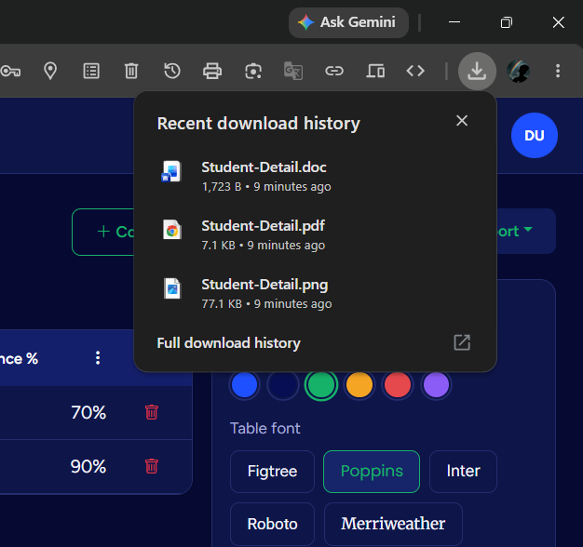

- assets/js/export.js
/* =====================================================================
TableCraft — Multi-format Export (PDF / DOC / PNG)
Requires (loaded via CDN in table_view.php):
- jsPDF + jspdf-autotable -> PDF export
- html2canvas -> PNG export
DOC export uses a browser-native "HTML to Word" blob (no library needed),
which Microsoft Word / WPS / LibreOffice all open correctly.
===================================================================== */

function tcGetTableTitle() {
const t = document.getElementById('tcTitleInput');
return (t ? t.textContent.trim() : 'TableCraft-Export') || 'TableCraft-Export';
}

function tcSafeFileName(str) {
return str.replace(/[^a-z0-9\-_ ]/gi, '').trim().replace(/\s+/g, '-') || 'tablecraft-table';
}

/* ---------------------------- PDF EXPORT -------------------------------- */
function exportTableToPDF() {
const state = window.TC_TableEngine.state;
const { jsPDF } = window.jspdf;
const doc = new jsPDF({ orientation: state.columns.length > 6 ? 'landscape' : 'portrait', unit: 'pt' });

const head = [state.columns.map((c) => c.column_name)];
const body = state.rows.map((row) =>
state.columns.map((col) => {
const cell = row.cells.find((c) => c.column_id === col.id);
return cell ? cell.value : '';
})
);

doc.setFontSize(16);
doc.setTextColor(8, 14, 83);
doc.text(tcGetTableTitle(), 40, 40);
doc.setFontSize(10);
doc.setTextColor(90, 95, 138);
doc.text('Generated with TableCraft', 40, 56);

doc.autoTable({
head, body,
startY: 72,
theme: 'grid',
headStyles: { fillColor: [8, 14, 83], textColor: 255, fontStyle: 'bold' },
styles: { font: 'helvetica', fontSize: 9, cellPadding: 6 },
alternateRowStyles: { fillColor: [247, 247, 247] }
});

doc.save(tcSafeFileName(tcGetTableTitle()) + '.pdf');
tcToast('PDF downloaded');
}

/* ---------------------------- PNG EXPORT -------------------------------- */
function exportTableToPNG() {
const area = document.getElementById('tcTableExportArea');
tcToast('Rendering image…');
html2canvas(area, { backgroundColor: getComputedStyle(document.documentElement).getPropertyValue('--surface') || '#ffffff', scale: 2 })
.then((canvas) => {
const link = document.createElement('a');
link.download = tcSafeFileName(tcGetTableTitle()) + '.png';
link.href = canvas.toDataURL('image/png');
link.click();
tcToast('PNG downloaded');
})
.catch(() => tcToast('Could not generate image', 'error'));
}

/* ---------------------------- DOC EXPORT -------------------------------- */
function exportTableToDOC() {
const state = window.TC_TableEngine.state;
const title = tcGetTableTitle();

let rowsHtml = '<tr>' + state.columns.map((c) => '<th style="background:#080E53;color:#ffffff;padding:8px;border:1px solid #ccc;">' + c.column_name + '</th>').join('') + '</tr>';
state.rows.forEach((row) => {
rowsHtml += '<tr>' + state.columns.map((col) => {
const cell = row.cells.find((c) => c.column_id === col.id);
return '<td style="padding:8px;border:1px solid #ccc;">' + (cell ? cell.value : '') + '</td>';
}).join('') + '</tr>';
});

const html = '<html xmlns:o="urn:schemas-microsoft-com:office:office" xmlns:w="urn:schemas-microsoft-com:office:word" xmlns="http://www.w3.org/TR/REC-html40">' +
'<head><meta charset="utf-8"><title>' + title + '</title></head>' +
'<body style="font-family:Calibri, Arial, sans-serif;">' +
'<h2 style="color:#080E53;">' + title + '</h2>' +
'<table style="border-collapse:collapse;width:100%;">' + rowsHtml + '</table>' +
'<p style="color:#5A5F8A;font-size:11px;margin-top:16px;">Generated with TableCraft</p>' +
'</body></html>';

const blob = new Blob(['\ufeff', html], { type: 'application/msword' });
const link = document.createElement('a');
link.href = URL.createObjectURL(blob);
link.download = tcSafeFileName(title) + '.doc';
link.click();
tcToast('DOC downloaded');
}

document.addEventListener('DOMContentLoaded', function () {
const pdfBtn = document.getElementById('exportPdfBtn');
const pngBtn = document.getElementById('exportPngBtn');
const docBtn = document.getElementById('exportDocBtn');
pdfBtn && pdfBtn.addEventListener('click', exportTableToPDF);
pngBtn && pngBtn.addEventListener('click', exportTableToPNG);
docBtn && docBtn.addEventListener('click', exportTableToDOC);
});

9. ERROR & SOLUTION

Problem | Solution
Database connection error | Centralized configuration and connection handling in config/db.php.
Invalid login | Email/password validation and password verification.
Duplicate registration | Existing-email check before insertion.
Password entry difficulty | Visibility toggle button.
Empty new table | Initial blank rows created automatically.
Outdated formulas | JavaScript recalculates formula columns on input changes.
Unauthorized table access | Verify table_id against current user_id.
Invalid color input | Validate hexadecimal color format.
Dynamic column mapping | Maintain column IDs and cell relationships during saving.

9.1 Database Connection Error

Problem
One of the basic errors that can occur in a PHP-MySQL application is failure to connect to the database.
If MySQL is not running in WampServer, or if the database name, username or password is incorrect, the application cannot retrieve or save data.
For example:
Connection failed: Access denied for user
or:
Unknown database 'tablecraft'

Possible Causes
- MySQL service is stopped.
- Database does not exist.
- Incorrect database name.
- Incorrect username/password.
- Incorrect host.
- PHP MySQL extension is unavailable.

Solution
The database connection was centralized inside:
config/db.php
The project uses the local MySQL environment:
Host: localhost
Database: tablecraft
User: root
The database connection is established before database-dependent operations are performed.

Result
Centralizing the database configuration makes the project easier to maintain and reduces duplicate connection code.

9.2 Database Not Found Error

Problem
If the tablecraft database has not been imported into phpMyAdmin, the application cannot find the required tables.

Error
Table 'tablecraft.users' doesn't exist

Solution
The supplied SQL file:
database/tablecraft.sql
must be imported through phpMyAdmin.
The database contains the required tables:
- users
- data_tables
- table_columns
- table_rows
- table_cells

Result
After importing the SQL file, the PHP application can communicate with the required MySQL tables.

9.3 Registration Validation Error

Problem
Users may enter incomplete or invalid information during registration.
Examples include:
- Empty name
- Invalid email
- Short password
- Different password and confirmation password
- Existing email address

Solution
Server-side validation is performed before creating the account.
The system checks:
Full Name
Email
Password
Confirm Password
The email address is also checked for existing accounts.

Result
Invalid registration data is rejected before it is inserted into the database.

9.4 Duplicate Email Error

Problem
A user may attempt to register multiple times using the same email address.
This could create duplicate accounts if no validation is performed.

Solution
Before inserting a new user, the application checks whether the email already exists.
Conceptually:
User enters email
↓
Search users table
↓
Email exists?
/ \
Yes No
↓ ↓
Show error Create account

Result
Duplicate user accounts are prevented.

9.5 Dynamic Row Error

Problem
The table editor allows users to add and delete rows dynamically.
If row indexes are not managed correctly, deleting a row may cause incorrect data to be associated with another row.

Solution
Rows are managed using database row identifiers and internal JavaScript state instead of relying only on visible row numbers.

Result
Rows can be added and deleted without incorrectly changing the identity of other stored rows.

9.6 Column Rename Error

Problem
When a user renames a column, the new name must be reflected in the table without affecting the existing cell values.

Solution
Column identity and column name are treated separately.
For example:
Column ID: 15
Old Name: Product
New Name: Product Name
The ID remains the same while only the displayed name changes.

Result
Existing data remains associated with the correct column.

9.7 Auto-Save / Save Error

Problem
Dynamic table changes exist initially in browser memory.
If they are not sent to the server, refreshing the page may cause changes to disappear.

Solution
The JavaScript table state is converted into a request and sent to:
api/save_table.php
The server then updates the MySQL database.

Result
Table changes can be persisted in the database.

9.8 Responsive Layout Error

Problem
A table containing many columns may not fit on a small screen.
This can cause horizontal overflow.

Solution
Responsive Bootstrap layouts and horizontally scrollable table containers can be used.
The table editor is designed so that users can access wide tables without breaking the overall page layout.

Result
The application remains usable on different screen sizes.

9.9 API Request Error

Problem
The browser may send an incomplete or invalid request to the PHP API.
For example:
Missing table ID
Missing table data
Invalid JSON

Solution
The API validates:
- Request method
- Required fields
- Table ID
- User ownership
- Data structure

Result
Invalid API requests are rejected instead of being processed incorrectly.

10. TESTING

Testing was performed to verify functional behavior, validation, database operations, table manipulation, interface behavior and export functions.

10.1 Test Cases
No. | Test Case | Expected Result
1 | Open application | Login page
2 | Valid registration | Account created
3 | Invalid email | Validation error
4 | Mismatched passwords | Error displayed
5 | Valid login | Dashboard opens
6 | Invalid login | Error displayed
7 | Select category | Category page
8 | Create table | Table created
9 | Add row | Row appears
10 | Delete row | Row removed
11 | Add column | Column appears
12 | Rename column | Name changes
13 | Move column | Position changes
14 | Quantity + price | Formula updates
15 | Accent color | Style changes
16 | Theme switch | Bright/Dark changes
17 | Save table | Data stored
18 | Search | Matching tables
19 | Filter | Selected category
20 | Delete | Table removed
21 | PDF | PDF downloaded
22 | DOC | DOC downloaded
23 | PNG | PNG downloaded

10.1 Black Box Testing

Black Box Testing is a software testing method in which the application's functionality is tested without examining its internal source code. The tester provides inputs and checks whether the system produces the expected outputs.

In the TableCraft project, Black Box Testing is used to verify registration, login, table creation, data entry, editing, saving, searching, filtering, automatic calculations, and exporting features.

Test Cases:

- Registration: Verify that users can register with valid details and that invalid inputs display appropriate error messages.

- Login: Check that registered users can log in with correct credentials and that incorrect credentials are rejected.

- Table Creation: Verify that tables are created with the correct category and default columns.

- Data Entry: Check whether users can add, edit, and delete rows and columns.

- Automatic Calculation: Verify that quantity, price, discount, and total calculations produce the expected results.

- Data Storage: Confirm that table data is saved to the database and remains available when reopened.

- Export: Check whether tables can be exported into PDF, DOC, and PNG formats.

Result: Black Box Testing helps verify that TableCraft's features work according to the specified requirements.

10.2 White Box Testing

White Box Testing is a software testing method in which the internal source code, logic, conditions, and program flow are examined. It helps identify logical errors and verify that the code works correctly.

In the TableCraft project, White Box Testing focuses on PHP scripts, JavaScript functions, database queries, session management, input validation, and automatic calculation logic.

Test Cases:

- Database Connection: Verify that the PHP database connection code connects to MySQL and handles connection failures appropriately.

- Input Validation: Examine the registration and login code to ensure that required fields and user credentials are validated correctly.

- Session Management: Check that session variables are created after successful login and that protected pages require authentication.

- SQL Queries: Verify that prepared statements correctly retrieve, insert, update, and delete database records.

- Table Ownership: Check that users can access and modify only their own saved tables.

- Calculation Logic: Examine JavaScript calculation functions to ensure that totals, discounts, and stock values are calculated correctly.

- Error Handling: Verify that invalid operations and database errors are handled appropriately.

Result: White Box Testing helps identify logical errors, improve code reliability, and verify the internal working of the TableCraft application.

10.3 Testing Methods
- Unit Testing — individual functions and modules.
- Integration Testing — connected workflows such as login → dashboard → table → save.
- System Testing — complete application workflow.
- UI Testing — forms, navigation, buttons, themes and responsive behavior.

11. IMPLEMENTATION

11.1 Requirements
- Windows computer
- WampServer
- Web browser
- phpMyAdmin

11.2 Installation Procedure
Step 1 — Install WampServer and start Apache and MySQL.
Step 2 — Copy the project into the WampServer www directory, for example C:\wamp64\www\tablecraft.
Step 3 — Open phpMyAdmin and import database/tablecraft.sql.
Step 4 — Open the TableCraft project through the local web server.

11.3 Demo Account
Field | Value
Email | demo@tablecraft.com
Password | Demo@123

11.4 Workflow
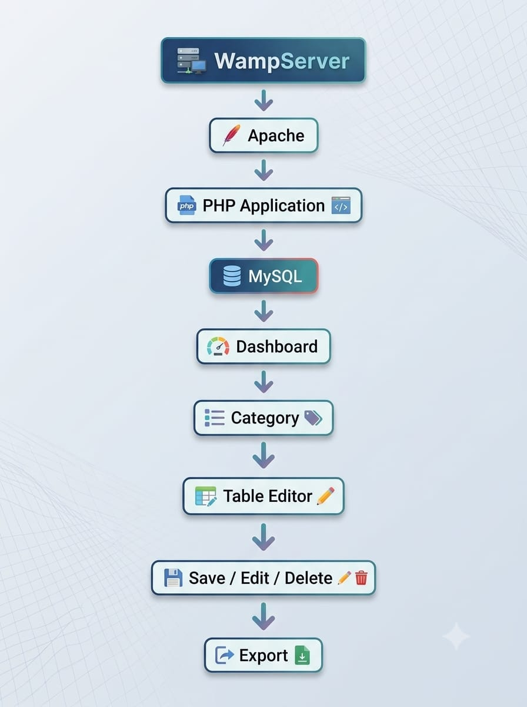

12. LIMITATIONS

- Primarily designed for WampServer/local deployment.
- External CDN resources may require internet connectivity.
- Advanced authentication such as email verification, password reset and 2FA is not included.
- Full role management is not included.
- Export formatting does not provide all advanced desktop publishing controls.
- Formula support is limited compared with spreadsheet software.
- Charts, pivot tables, macros and advanced spreadsheet functions are outside the current scope.
- Automated cloud backup is not included.

13. CONCLUSION

13.1 Conclusion
TableCraft – An Automated Multi-Category Data Formatting Web Application was successfully designed and developed as a web-based data formatting system. Its primary objective is to provide a simple platform where users can enter information and convert it into structured, editable and visually attractive tables.
The application combines HTML5, CSS3, Bootstrap 5, JavaScript, PHP and MySQL. It provides Student Record, Shop Order, Employee Info, Library Book List, Product Stock, Commercial Category and Custom Category Editor modules.
The dynamic table editor allows users to add and delete rows, add and rename columns, move columns, edit cells and customize table appearance. Automatic calculations improve usability for quantity, price, stock and commercial totals.
The authentication system provides separate user accounts and the database structure associates tables with their respective users. The My Tables module provides centralized search, filtering, editing and deletion of saved tables.
The export system provides PDF, DOC and PNG output. The project also provided practical experience in web development, PHP, MySQL, JavaScript, API design, session management, responsive UI, validation, testing and file export.

13.2 Future Scope
- Cloud deployment.
- Advanced user roles.
- Automatic cloud backup.
- Advanced formulas.
- Charts and graphs.
- XLSX export.
- Advanced PDF customization.
- Secure table sharing.
- Mobile application.
- AI-assisted table generation.

PROJECT SUMMARY
Item | Details
Project Name | TableCraft
Project Type | Web Application
Purpose | Automated Multi-Category Data Formatting
Frontend | HTML5, CSS3, Bootstrap 5, JavaScript
Backend | PHP
Database | MySQL
Server | Apache / WampServer
Authentication | Login & Registration
Categories | 7
Dynamic Editing | Yes
Themes | Bright & Dark
Customization | Font & Accent Color
Automatic Calculation | Yes
Search / Filter | Yes
Exports | PDF / DOC / PNG
Database Tables | 5
Responsive UI | Yes

FINAL PROJECT WORKFLOW
